AGENDA

Planning Commission Meeting April 3, 2023
6:00 p.m.

Meeting Location:
Grantville City Hall – Council Chambers 123 LaGrange Street
Grantville, GA 30220

Audio Conference Number: 425-436-6364 Access Code: 336977#

CALL TO ORDER ATTENDANCE
REVIEW & APPROVAL OF MINUTES

March 6, 2023 Planning Commission Meeting

REPORT OF COMMITTEES UNFINISHED BUSINESS HEARING OF CASES
NEW BUSINESS

Text Amendment Article 14.6-2 – Non-Business Signs, Table 14.2 Maximum Number of Non-Business Signs. The text amendment language is attached to the agenda.

The proposed text amendment allows for a larger size for directional signs.

Text Amendment Article 4 Zoning Districts and Boundaries, Section 4.1 Section 4.1-12 – Historic Mill Village Zoning District, Table 5.1, and Table 5.3 The text amendment language is attached to the agenda.

ADJOURNMENT

Page 1

Grantville Planning Commission Meeting Minutes

Date: March 6, 2023
Time: 6:00 p.m.
Location: Grantville City Hall, 123 LaGrange Street Grantville, Georgia 30220
and by Audio Conference Number: 425-436-6364 Access Code: 336977# Mr. Ward called the Planning Commission meeting to order at 6:00 p.m.

Attendance
Joe Ward, Vice Chairman Danny Clay
Robin Bugg
Brenda Maddox (by conference call) Brennan Jones, Zoning Administrator

Public Attendance
Richard Proctor

Review & Approval of Minutes
Adoption of Planning Commission Meeting Minutes from February 6, 2023
Planning Commission meeting minutes for the meeting held on February 6, 2023, were distributed to the members for review and adoption. After review of the minutes, Mr. Clay made a motion to adopt the February, 2023, Planning Commission Meeting Minutes. Mrs. Bugg seconded the motion. After discussion, Mr. Ward called for a vote and the motion passed unanimously.

Report of Committees
Mr. Jones stated that he provided examples of development agreements to Mr. Raptis for his review in response to the request from Mr. Raptis at the February meeting.

Unfinished Business
None

Hearing of Cases
None

New Business
Final Plat for Minor Subdivision for parcel G06 0002 015 (7.39Acres)
Mr. Jones presented a final plat application for a minor subdivision of the parcel G06 0002 015, address 9 Holtzclaw Rd. The property is zoned in the (R-20) Single Family Residential Zoning District. The minor subdivision will create four (4) parcels. The parcels created by the minor subdivision conform to minimum lot size and setback requirements for the zoning district.

Page 1 of 2

Mr. Clay made a motion to approve the final plat for the property line revision for parcel G06 0002 015 as submitted by the applicant. Mrs. Maddox seconded the motion. After discussion, Mr. Ward called for a vote and the motion passed unanimously.

Discussion concerning parcel sizes, minimum home sizes, and increasing residential zoning density. Mr. Jones stated that the City Council may be considering adding a new zoning district in the older parts of Grantville that will allow for a smaller lot size and a smaller minimum house square footage size. The planning commissioners had a discussion concerning this issue. Following the discussion, Mr. Ward recognized Mayor Proctor and he addressed and discussed with the Planning Commission parcel sizes, minimum home sizes, and increasing residential zoning density. No action was taken by the planning commission on this matter.

Adjournment
Mr. Clay made a motion to adjourn the meeting. Mrs. Bugg seconded the motion. Mr. Ward adjourned the Planning Commission Meeting at 7:00 p.m.

Page 2 of 2

SURVEYORS CERTIFICATION
AS REQUIRED BY SUBSECTION (c) OF O.C.G.A. SECTION 15-6-67, THE REGISTERED LAND SURVEYOR HEREBY CERTIFIES THAT THIS MAP, PLAT, OR PLAN HAS BEEN APPROVED FOR FILING IN WRITING BY ANY AND ALL APPLICABLE MUNICIPAL, COUNTY, OR GOVERNING AUTHORITIES OR THAT SUCH GOVERNMENTAL BODIES HAVE AFFIRMED IN WRITING THAT
APPROVAL IS NOT REQUIRED.

GREGORY $COTT HAJEK 02/27/2023
NOTES:
- The term ³Certification´ as used in Rule ³ 180-6-.09(2) and (3)* and relating to professional engineering or land surveying services, as defined in O.C.G.A.
43-15-2(6) and ( 11), shall mean a signed statement based upon facts and knowledge known to the registrant and is not a guarantee or warranty, either expressed or implied.
- This Survey complies with both the rules of Georgia Boord of Registration for Professional Engineers and Land Surveyors and the Official Code of Georgia Annotated (OCGA) 15-6-67, in that where a conflict exists between those two sets of specifications, the requirements of low prevail.
- All iron pins found or set ore 1/2" rebor unless otherwise noted.
- This property may be subject to Easements, Rights of Way or Restrictions that

GREGORY S. HAJEK GA. PLS # 3214
DATE:
ore not of record or that would have been discovered by a current Title Search.
- Improvements shown for illustration purposes only and were overlayed using
...9QQ9.le imagery. No field work done for this survey at this time, this plat is preliminary only.
- Property is zoned: R-20

THIS BLOCK RESERVED FOR THE CLERK OF THE SUPERIOR COURT

FINAL PLAT APPROVAL CERTIFICATION
This Final Plat has been prepared in accordance with the Land Subdivision Regulations of the City of Grantville, Georgia. All the requirements of approval having been fulfilled, this plot was approved by the City of Grantville Planning Commission at its meeting on Morch 6, 2023, and it has been approved by the City for recording in the Office of the Clerk of the Superior Court
Minimum lot area= 20,000 SF.- 1.0 AC. Minimum lot-width @ setback= 80 FT. Front yard Arterial & Collector= 40/25 FT. Side yard= 15 FT.
Rear yard= 30 FT.
Maximum Bid. height= 35 FT.

•

Chairman, Planning Commission DATE:

ERERTER

CMP

1" OT

FH

(XJ

(!)
OJ

1/2"

-,

3/4" SB

CALLS ALONG PROPERTY LIN

LINE | BEARING | DISTANC
L1 | N 63"29'34" E | 79.95'
L2 | S 28°04'26" E | 20.00'
L3 | N 28"28'26" W | 20.00'
LS | S 1744'35" E | 134.74
L6 | S 01"24'14" W | 17.00'
L7 | S 0735'17" E | 31.51'
LB | S 11"04'31" E | 55.81'

IRON PIN FOUND
•
- CONCRETE MONUMENT FOUND

'61.. PM POWER METER
NOT TO SCALE

-w- WATER PIPELINE
-G- NATURAL GAS PIPELINE

THE FIELD DATA UPON WHICH THIS PLAT IS BASED HAS A
RY SUBDIVISION
STATE OF GEORGIA, COWETA COUNTY, CITY OF GRANTVILLE

0
□
'S.PP
1/2" REBAR W/CAP SET
CONCRETE MONUMENT SET POWER POLE

C/L CENTERLINE
POB POINT OF BEGINNING

-S- SANITARY SEWER LINE
(I) MANHOLE
CLOSURE OF ONE FOOT IN > 5,000 I, Gregory Scott Hajek, a Licensed Land Surveyor in the State of Georgia, do hereby certify that the above plat or
FEET AND AN ANGULAR ERROR OF < 2" map is a true and accurate representation of a survey conducted under my direction; that the structures now erected

LP '61..TP TB
p
T HW
RCP RB
LAMP POST TELEPHONE POLE TELEPHONE BOX OVERHEAD POWER OVERHEAD TELEPHONE HEADWALL
REINFORCED CONCRETE PIPE REBAR
DB DEED BOOK
PB PLAT BOOK
PG PAGE
B/L MINIMUM BUILDING LINE R/W RIGHT OF WAY
OT OPEN TOP PIPE
-X- FENCE LINE
[)e(J WV WATER VALVE
Ill WM WATER METER
(R) RECORD
LL LAND LOT
LO LAND DISTRICT
ti. CALCULATED POINT FH FIRE HYDRANT
SB SOLID BAR
PER ANGLE POINT, AND WAS ADJUSTED USING THE COMPASS RULE
THIS PLAT HAS BEEN CALCULATED FOR CLOSURE AND
FOUND TO BE ACCURATE TO WITHIN ONE FOOT IN > 10,000
FEET. ANGLES AND DISTANCES WERE MEASURED WITH NIKON DM2A20 TOTAL STATION. MIN. DIRECT ANGLE READING 5.0"
FIELD WORK WAS COMPLETED ON 02/26/2023.
on said property are within the boundaries of some, except as shown hereon; that there ore no encroachments on
said property by structures erected on adjoining property, except as shown hereon; that there are no easements, joint driveways, or rights of way, on, over or across said property, visible on the surface, except as shown hereon.This property is not located within the 100 year flood zone, as delineated on Coweta Co. FIRM: 13077C 03520, Dated Febuary 6, 2013.

NOT A VALID OR RECORDABLE PLAT OR MAP UNLESS SIGNED ACROSS SEAL WITH ORIGINAL SIGNATURE OF SURVEYOR
REFERENCES: DB 4684, PG 91; PB 16,
PG 247.

Stothard Surveying, Inc.
1008 Colquitt St. LaGrange, Georgia 30241
Ph: (706) 884-5279
www.stothordlondsurveying.com emoil: stothordsurveying@gmoil.com

- G-RAPHIC SCALE
--­
REVISION:
NO: BY: DATE:

DESCRIPTION:

Gt,,ORGl<l
c;\STf,i;, <:>

* No. 3214 *
SUBDIVISION FOR:

JEFF FISHER JAMIE FISHER
A SUBDIVISION OF PARCEL # G06 000 2 015, PER PLAT BOOK 16, PAGE 247 COWETA COUNTY RECORDS.

BEARING BASIS:
PLAT BOOK 89, PAGE 64
0 100

( IN FEET )
200
300
COUNTY:
COWETA DATE:
LAND LOT:
269
DWG. NO. COG 23-01
LAND DISTRICT:
2ND
C SCALE (ORIGINAL):

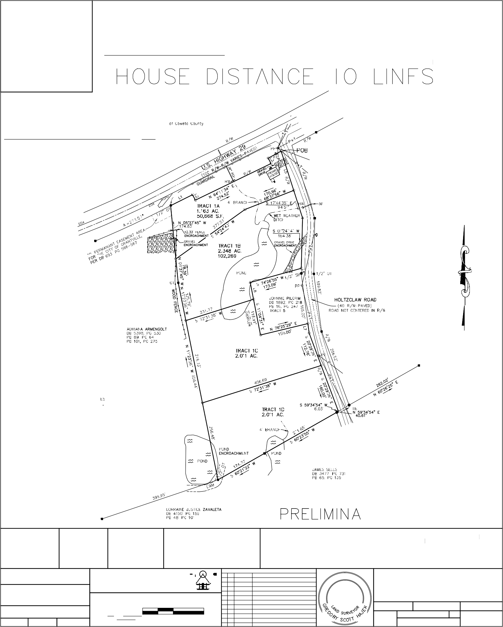
FIELDWORK DO&GH
CALC/DWG
DG
CHECK
HD
1 inch= 100 ft.
02/27/23
CAD FILE: G:\SURVEY\GEORGIA\ COWETA\9HOLTZCLAW-C
1"= 100'

Grantville Zoning Ordinance Proposed Text Amendment Article 14.6-2 – Non-Business Signs, Table 14.2

April 6, 2023

- Name and address of applicant.
Brennan Jones, Zoning Administrator 123 LaGrange Street
Grantville, GA 30220

- Current provisions of text to be affected by amendment.

Replace the existing text:

Table 14.2 Maximum Number of Non-Business Signs

Sign Purposes | Maximum Number of Signs | Max Size | Required  Setback From R-O-W Line
Announcing Sign | 1 per lot | 10 sq. ft. | 10′
Commemorative Sign | 1 per lot | 10 sq. ft. | 10′
Directional Sign | 2 per a single location: each location is 100′ from other location | 4 sq. ft. | —
Identification Sign | Residential Subdivision & Manufactured Home Park | 64 sq. ft. | 10′
 | Residential Dwelling: 1 per family | 2 sq. ft. | 3′
 | Non-Residential Unit: 1 per road frontage | 64 sq. ft. | 10′
Instructional Sign | Varies according to need | 4 sq. ft. | —

Permitted Sign Types: Ground, wall or canopy signs only. With the following text:
Table 14.2 Maximum Number of Non-Business Signs

Sign Purposes | Maximum Number of Signs | Max Size | Required  Setback From R-O-W Line
Announcing Sign | 1 per lot | 10 sq. ft. | 10′
Commemorative Sign | 1 per lot | 10 sq. ft. | 10′
Directional Sign | 2 per a single location: each location is 100′ from other location | 16 sq. ft. | —
Identification Sign | Residential Subdivision & Manufactured Home Park | 64 sq. ft. | 10′
 | Residential Dwelling: 1 per family | 2 sq. ft. | 3′
 | Non-Residential Unit: 1 per road frontage | 64 sq. ft. | 10′
Instructional Sign | Varies according to need | 4 sq. ft. | —

- Reason for amendment request.
The text amendment allows for a larger size for directional signs.

Grantville Zoning Ordinance Proposed Text Amendment Articles 4.1-12, Table 5.1, Table 5.3

April 6, 2023

- Name and address of applicant.
Mayor and City Council 123 LaGrange Street
Grantville, GA 30220

- Current provisions of text to be affected by amendment.

Add the following to the zoning district table Section 4.1:

HMV | Historic Mill Village District

Add the following text for Section 4.1-12 below Section 4.1-11.5:

4.1-12 Historic Mill Village (HMV) The purpose of this district is to recognize the distinctive nature of the City’s historic Mill Village area and to encourage residential development that is consistent with the area, including accommodating higher density single family residences of approximately eight (8) units per acre.

Add the following text to Table 5.1:

Table 5.1: Zoning District Area Yard and Height Requirements

Zoning District | Minimum Lot Area | Min. Lot Width at Setback  Line (feet) | Front Yard from Arterial & Collector/Local  Street (feet)* | Side Yard (feet) | Rear Yard (feet) | Max. Building Height  (feet)
HMV | 1/8 acre | 50 | 20 | 7.5 | 20 | 35

Add HMV Zoning District column to Table 5.3 – Permitted Use Schedule as shown below:

TABLE 5.3 - PERMITTED USE SCHEDULE

Use Type | SIC | Zoning Districts
 |  | RD | R 20 | NUP | R 6 | CR | PR | OI | GC | LM | GI | HMV
Dwelling Single-Family Type 1 | 0000 | P | P | S | P | P |  |  |  |  |  | P

- Reason for amendment request.
The text amendment is requested by the Mayor and City Council to allow for higher density housing in the Mill Village Area with lot sizes that are similar to the existing lot sizes in the Mill Village area.

ORDINANCE NO.

AN ORDINANCE OF THE MAYOR AND COUNCIL OF THE CITY OF GRANTVILLE, GEORGIA AMENDING THE ZONING ORDINANCE OF THE CITY OF GRANTVILLE TO MAKE THE FOLLOWING TEXT AMENDMENTS TO THE ORDINANCE AMEND ARTICLE 4 ZONING DISTRICTS BY ADDING HISTORIC MILL VILLAGE (HMV); A ND FOR OTHER PURPOSES

WHEREAS, the Mayor and Council of the City of Grantville have determined that it is in the best interest of the City to amend the Zoning Ordinance of the City of Grantville;

The Mayor and Council of the City of Grantville, Georgia hereby ordain as follows:

Section 1.

Article 4. Zoning Districts and Boundaries is amended as follows:

  - Section 4.1 is amended by adding the following district: HMV Historic Mill Village
  - Section 4.1 is amended by adding the following subsections:

Section 2.
4.1-12 Historic Mill Village (HMV) The purpose of this district is to recognize the distinctive nature of the City’s historic Mill Village area and to encourage residential development that is consistent with the area, including accommodating higher density single family residences of approximately eight (8) units per acre.

All ordinances or parts of ordinances in conflict with this ordinance are repealed.

First Reading:

SO ORDAINED in lawfully assembled open session this
, 2012.
day of

MAYOR

Attest: Clerk

