AGENDA

Planning Commission Meeting March 6, 2023
6:00 p.m.

Meeting Location:
Grantville City Hall – Council Chambers 123 LaGrange Street
Grantville, GA 30220

Audio Conference Number: 425-436-6364 Access Code: 336977#

CALL TO ORDER ATTENDANCE
REVIEW & APPROVAL OF MINUTES

February 6, 2023 Planning Commission Meeting

REPORT OF COMMITTEES

Review of Example Development Agreement
UNFINISHED BUSINESS HEARING OF CASES NEW BUSINESS

Final Plat for Minor Subdivision for parcel G06 0002 015 (7.39Acres)
An application for a minor subdivision of the parcel G06 0002 015 (9 Holtzclaw Rd), was submitted by the property owner. The property is zoned in the (R-20) Single Family Residential Zoning District. The minor subdivision will create 4 parcels. The parcels created by the minor subdivision conform to minimum lot size and setback requirements for the zoning district.

ADJOURNMENT

Page 1

SURVEYORS CERTIFICATION
AS REQUIRED BY SUBSECTION (c) OF O.C.G.A. SECTION 15-6-67, THE REGISTERED LAND SURVEYOR HEREBY CERTIFIES THAT THIS MAP, PLAT, OR PLAN HAS BEEN APPROVED FOR FILING IN WRITING BY ANY AND ALL APPLICABLE MUNICIPAL, COUNTY, OR GOVERNING AUTHORITIES OR THAT SUCH GOVERNMENTAL BODIES HAVE AFFIRMED IN WRITING THAT
APPROVAL IS NOT REQUIRED.

GREGORY $COTT HAJEK 02/27/2023
NOTES:
- The term ³Certification´ as used in Rule ³ 180-6-.09(2) and (3)* and relating to professional engineering or land surveying services, as defined in O.C.G.A.
43-15-2(6) and ( 11), shall mean a signed statement based upon facts and knowledge known to the registrant and is not a guarantee or warranty, either expressed or implied.
- This Survey complies with both the rules of Georgia Boord of Registration for Professional Engineers and Land Surveyors and the Official Code of Georgia Annotated (OCGA) 15-6-67, in that where a conflict exists between those two sets of specifications, the requirements of low prevail.
- All iron pins found or set ore 1/2" rebor unless otherwise noted.
- This property may be subject to Easements, Rights of Way or Restrictions that

GREGORY S. HAJEK GA. PLS # 3214
DATE:
ore not of record or that would have been discovered by a current Title Search.
- Improvements shown for illustration purposes only and were overlayed using
...9QQ9.le imagery. No field work done for this survey at this time, this plat is preliminary only.
- Property is zoned: R-20

THIS BLOCK RESERVED FOR THE CLERK OF THE SUPERIOR COURT

FINAL PLAT APPROVAL CERTIFICATION
This Final Plat has been prepared in accordance with the Land Subdivision Regulations of the City of Grantville, Georgia. All the requirements of approval having been fulfilled, this plot was approved by the City of Grantville Planning Commission at its meeting on Morch 6, 2023, and it has been approved by the City for recording in the Office of the Clerk of the Superior Court
Minimum lot area= 20,000 SF.- 1.0 AC. Minimum lot-width @ setback= 80 FT. Front yard Arterial & Collector= 40/25 FT. Side yard= 15 FT.
Rear yard= 30 FT.
Maximum Bid. height= 35 FT.

•

Chairman, Planning Commission DATE:

ERERTER

CMP

1" OT

FH

(XJ

(!)
OJ

1/2"

-,

3/4" SB

CALLS ALONG PROPERTY LIN

LINE | BEARING | DISTANC
L1 | N 63"29'34" E | 79.95'
L2 | S 28°04'26" E | 20.00'
L3 | N 28"28'26" W | 20.00'
LS | S 1744'35" E | 134.74
L6 | S 01"24'14" W | 17.00'
L7 | S 0735'17" E | 31.51'
LB | S 11"04'31" E | 55.81'

IRON PIN FOUND
•
- CONCRETE MONUMENT FOUND

'61.. PM POWER METER
NOT TO SCALE

-w- WATER PIPELINE
-G- NATURAL GAS PIPELINE

THE FIELD DATA UPON WHICH THIS PLAT IS BASED HAS A
RY SUBDIVISION
STATE OF GEORGIA, COWETA COUNTY, CITY OF GRANTVILLE

0
□
'S.PP
1/2" REBAR W/CAP SET
CONCRETE MONUMENT SET POWER POLE

C/L CENTERLINE
POB POINT OF BEGINNING

-S- SANITARY SEWER LINE
(I) MANHOLE
CLOSURE OF ONE FOOT IN > 5,000 I, Gregory Scott Hajek, a Licensed Land Surveyor in the State of Georgia, do hereby certify that the above plat or
FEET AND AN ANGULAR ERROR OF < 2" map is a true and accurate representation of a survey conducted under my direction; that the structures now erected

LP '61..TP TB
p
T HW
RCP RB
LAMP POST TELEPHONE POLE TELEPHONE BOX OVERHEAD POWER OVERHEAD TELEPHONE HEADWALL
REINFORCED CONCRETE PIPE REBAR
DB DEED BOOK
PB PLAT BOOK
PG PAGE
B/L MINIMUM BUILDING LINE R/W RIGHT OF WAY
OT OPEN TOP PIPE
-X- FENCE LINE
[)e(J WV WATER VALVE
Ill WM WATER METER
(R) RECORD
LL LAND LOT
LO LAND DISTRICT
ti. CALCULATED POINT FH FIRE HYDRANT
SB SOLID BAR
PER ANGLE POINT, AND WAS ADJUSTED USING THE COMPASS RULE
THIS PLAT HAS BEEN CALCULATED FOR CLOSURE AND
FOUND TO BE ACCURATE TO WITHIN ONE FOOT IN > 10,000
FEET. ANGLES AND DISTANCES WERE MEASURED WITH NIKON DM2A20 TOTAL STATION. MIN. DIRECT ANGLE READING 5.0"
FIELD WORK WAS COMPLETED ON 02/26/2023.
on said property are within the boundaries of some, except as shown hereon; that there ore no encroachments on
said property by structures erected on adjoining property, except as shown hereon; that there are no easements, joint driveways, or rights of way, on, over or across said property, visible on the surface, except as shown hereon.This property is not located within the 100 year flood zone, as delineated on Coweta Co. FIRM: 13077C 03520, Dated Febuary 6, 2013.

NOT A VALID OR RECORDABLE PLAT OR MAP UNLESS SIGNED ACROSS SEAL WITH ORIGINAL SIGNATURE OF SURVEYOR
REFERENCES: DB 4684, PG 91; PB 16,
PG 247.

Stothard Surveying, Inc.
1008 Colquitt St. LaGrange, Georgia 30241
Ph: (706) 884-5279
www.stothordlondsurveying.com emoil: stothordsurveying@gmoil.com

- G-RAPHIC SCALE
--­
REVISION:
NO: BY: DATE:

DESCRIPTION:

Gt,,ORGl<l
c;\STf,i;, <:>

* No. 3214 *
SUBDIVISION FOR:

JEFF FISHER JAMIE FISHER
A SUBDIVISION OF PARCEL # G06 000 2 015, PER PLAT BOOK 16, PAGE 247 COWETA COUNTY RECORDS.

BEARING BASIS:
PLAT BOOK 89, PAGE 64
0 100

( IN FEET )
200
300
COUNTY:
COWETA DATE:
LAND LOT:
269
DWG. NO. COG 23-01
LAND DISTRICT:
2ND
C SCALE (ORIGINAL):

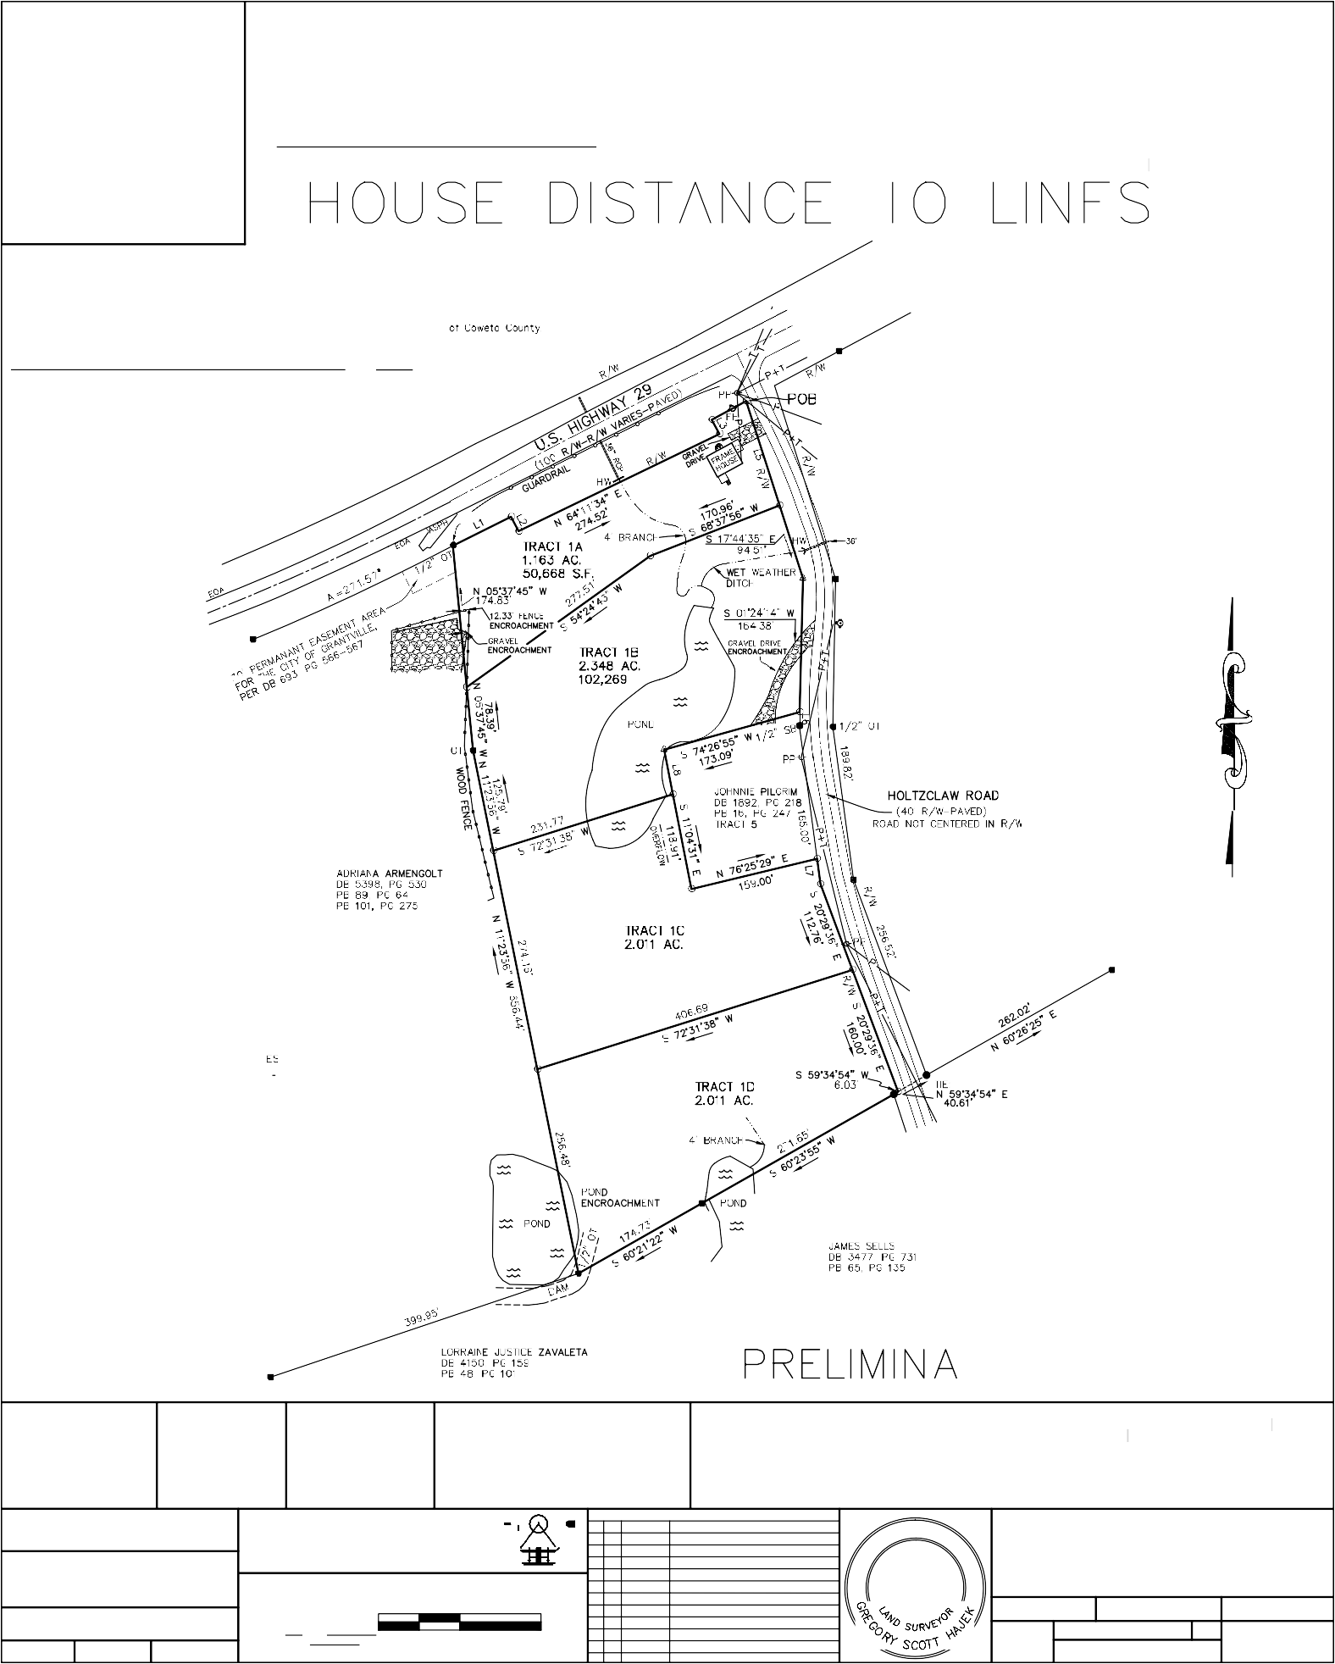
FIELDWORK DO&GH
CALC/DWG
DG
CHECK
HD
1 inch= 100 ft.
02/27/23
CAD FILE: G:\SURVEY\GEORGIA\ COWETA\9HOLTZCLAW-C
1"= 100'

Grantville Planning Commission Meeting Minutes

Date: February 6, 2023
Time: 6:00 p.m.
Location: Grantville City Hall, 123 LaGrange Street Grantville, Georgia 30220
and by Audio Conference Number: 425-436-6364 Access Code: 336977# Mr. Raptis called the Planning Commission meeting to order at 6:00 p.m.
Attendance
Tyree Raptis, Chairman Joe Ward, Vice Chairman Danny Clay
Robin Bugg
Brenda Maddox (by conference call) Brennan Jones, Zoning Administrator

Public Attendance Richard Proctor Brandon McDowell Richard Ferry

Review & Approval of Minutes
Adoption of Planning Commission Meeting Minutes from January 5, 2023
Planning Commission meeting minutes for the meeting held on January 5, 2023, were distributed to the members for review and adoption. After review of the minutes, Mr. Ward made a motion to adopt the January 5, 2023, Planning Commission Meeting Minutes. Mr. Clay seconded the motion. After discussion, Mr. Raptis called for a vote and the motion passed unanimously.

Report of Committees
None

Unfinished Business
None

Hearing of Cases
None

New Business
Final Plat for Property Line Revision for parcels G01-2238-020 and G03-0009-0022
Mr. Jones presented a final plat application for a property line revision for parcels G01-2238-020 and G03-0009-0022 via a land swap of equivalent area. The parcels are in the Rural Development (RD) Zoning District.

Page 1 of 2

Ms. Bugg made a motion to approve the final plat for the property line revision for parcels G01- 2238-020 and G03-0009-0022 as submitted by the applicants. Mr. Ward seconded the motion. After discussion, Mr. Raptis called for a vote and the motion passed unanimously.

Final Plat for Minor Subdivision for parcel G01-2238-020 (4.89 Acres)
Mr. Jones presented a final plat application for a minor subdivision of the parcel G01-2238-020. The property is zoned in the Rural Development (RD) Zoning District. The minor subdivision will create two parcels. The parcels created by the minor subdivision conform to minimum lot size and setback requirements for the zoning district.

Ms. Bugg made a motion to approve the final plat for the property line revision for parcel G01- 2238-020 as submitted by the applicant. Mr. Ward seconded the motion. After discussion, Mr. Raptis called for a vote and the motion passed unanimously.

Preliminary Plat for Greyland Farms Subdivision for parcel 054 2242 002 (95.7 Acres)
Mr. Jones presented a, application for a subdivision of the parcel 054 2242 002. The property is zoned in the R-20 Residential Zoning District. The planned residential subdivision includes 113 parcels. The parcels generally conform to minimum lot size and setback requirements for the zoning district. Mr. Ferry was recognized by the Planning Commission to discuss the planned development and to answer question concerning the planned development.

Ms. Bugg made a motion to approve the preliminary plat for Greyland Farms Subdivision for parcel 054 2242 002 as submitted by the applicant. Mr. Ward seconded the motion. After discussion, Mr. Raptis called for a vote, which resulted in R. Bugg, J. Ward and B. Maddox voting to approve, and
D. Clay abstained. The motion passed.

Review Water System Capital Improvement Plan (CIP)
Mr. Jones presented an overview of the Grantville water System Capital Improvement Plan (CIP) technical memorandum and exhibit dated January 25, 2023. Mr. Jones discussed that the CIP would improve potable water supply for domestic and fire protection, improve water quality by looping dead ends in the water system and provide for other improvements such as valve installations and fire hydrant replacements. No action by the Planning Commission was required for this item.

Direction from the Chairman
Mr. Raptis directed Mr. Jones to investigate and provide an example of a development agreement related to infrastructure improvements for review by the Planning Commission.

Adjournment
Mr. Clay made a motion to adjourn the meeting. Mr. Ward seconded the motion. Mr. Raptis adjourned the Planning Commission Meeting at 6:50 p.m.

Page 2 of 2

THIS BLOCK RESERVED FOR THE CLERK OF THE SUPERIOR COURT.
CLOSURE STATEMENT:

THE FIELD DATA UPON WHICH THIS PLAT IS BASED HAS A CLOSURE PRECISION OF ONE FOOT IN 25,000 FEET AND AN ANGULAR ERROR OF 02" PER ANGLE POINT AND WAS ADJUSTED USING LEAST SQUARE RULE.

THIS PLAT HAS BEEN CALCULATED FOR CLOSURE AND
IS FOUND TO BE ACCURATE WITHIN ONE FOOT IN 100,000+ FEET. TYPE OF EQUIPMENT USED: TOPCON GTS 313
152.09'
N37°54'00"E

E.O.P. | = | EDGE OF PAVEMENT
R/W | = | RIGHT OF WAY
I.P.F. | = | IRON PIN FOUND
I.P.P. | = | IRON PIN PLACED
C.T. | = | CRIMPED TOP PIPE
R.B. | = | REINFORCING BAR
O.T. | = | OPEN TOP
N/F | = | NOW OR FORMERLY
B/L | = | BUILDING LINE
P.P. | = | POWER POLE
L.L.L. | = | LAND LOT LINE
D.B. | = | DEED BOOK
P.B. | = | PLAT BOOK
C.M.F. | = | CONCRETE MONUMENT FOUND
P.O.B. | = | POINT OF BEGINNING
A.K.A. | = | ALSO KNOWN AS
U.E. | = | UTILITY EASEMENT
D.E. | = | DRAINAGE EASEMENT
L.P. | = | LIGHT POLE
F.H. | = | FIRE HYDRANT
W.M. | = | WATER METER
M.F.F.E. | = | MINIMUM FINISHED
 |  | FLOOR ELEVATION
L.A.G. | = | LOWEST ADJACENT GRADE
H.A.G. | = | HIGHEST ADJACENT GRADE
D.I. | = | DROP INLET
J.B. | = | JUNCTION BOX
C.B. | = | CATCH BASIN
T.B.M. | = | TEMPORARY BENCHMARK

THIS PROPERTY DOES NOT LIE WITHIN A SPECIAL FLOOD HAZARD AREA AS IDENTIFIED BY FEMA FLOOD INSURANCE RATE MAP NUMBER 13077C0351D WITH AN EFFECTIVE DATE OF FEBRUARY 6, 2013.

BOHANNON ROAD ~ 60' R/W
124.84'
S37°54'00"W

THIS SURVEY WAS PREPARED WITHOUT THE BENEFIT OF AN ABSTRACT TITLE; THEREFORE, THE UNDERSIGNED AND MCLAIN SURVEYING, INC., MAKE NO GUARANTEES OR REPRESENTATIONS REGARDING INFORMATION SHOWN HEREON PERTAINING TO EASEMENTS, RIGHTS OF WAY, SETBACK LINES, AGREEMENTS, RESERVATIONS AND OTHER SIMILAR MATTERS.

As required by subsection (c) of O.C.G.A. Section 15-6-67, this map or plat has been prepared and issued for submittal and approval by the local jurisdiction as is evidenced by the approval certificates, signatures, stamps, or statements hereon.
Such approvals or affirmations should be confirmed with the appropriate governmental bodies by any purchaser or user of the survey or map as to intended use of any parcel. Further, the undersigned land surveyor certifies that this map, plat, or plan complies with the minimum technical standards for property surveys in Georgia as set forth in Chapter 180-7 of the Rules of the Georgia Board of Registration for Professional Engineers and Land Surveyors and as set forth in the Georgia Plat Act OCGA 15-6-67.
N52°10'20"W
N52°10'20"W 404.03'
152.13'
EDGE OF PAVEMENT
L1

McLAIN SURVEYING, INC.
EDGE OF PAVEMENT
LAND SURVEYING - LAND PLANNING - LAND DEVELOPMENT

6 MADISON STREET
NEWNAN, GEORGIA 30263
PHONE: 770-251-8523 - EMAIL: tmclain339@numail.org

LEGEND
N37°54'00"E
288.78'
S37°54'00"W 500.00'

© Copyright - 2018 | Mclain Surveying Inc. | All Rights Reserved
SURVEY FOR:

REDBIRD HOMES
TAX PARCELS G01 2238 020 &
A PORTION OF G03 0009 002 LAND LOTS 238 & 239 - 2ND. DISTRICT
COWETA COUNTY, GEORGIA
IN MY OPINION, THIS IS A TRUE AND CORRECT REPRESENTATION OF THE PLATTED PROPERTY AND HAS BEEN PREPARED IN CONFORMITY WITH THE STANDARDS AND REQUIREMENTS OF LAW.
RANDY MCLAIN GEORGIA R.L.S. #2703
DATE: JULY 14, 2022 | ISSUE
SCALE: 1"=60' | No. | DESCRIPTION | DATE
ACREAGE: AS SHOWN
CITY: GRANTVILLE
DRAWN: TM
CHECKED: RM
PROJECT #: 21-345

THIS BLOCK RESERVED FOR THE CLERK OF THE SUPERIOR COURT.
CLOSURE STATEMENT:

THE FIELD DATA UPON WHICH THIS PLAT IS BASED HAS A CLOSURE PRECISION OF ONE FOOT IN 25,000 FEET AND AN ANGULAR ERROR OF 02" PER ANGLE POINT AND WAS ADJUSTED USING LEAST SQUARE RULE.

THIS PLAT HAS BEEN CALCULATED FOR CLOSURE AND
IS FOUND TO BE ACCURATE WITHIN ONE FOOT IN 100,000+ FEET. TYPE OF EQUIPMENT USED: TOPCON GTS 313

E.O.P. | = | EDGE OF PAVEMENT
R/W | = | RIGHT OF WAY
I.P.F. | = | IRON PIN FOUND
I.P.P. | = | IRON PIN PLACED
C.T. | = | CRIMPED TOP PIPE
R.B. | = | REINFORCING BAR
O.T. | = | OPEN TOP
N/F | = | NOW OR FORMERLY
B/L | = | BUILDING LINE
P.P. | = | POWER POLE
L.L.L. | = | LAND LOT LINE
D.B. | = | DEED BOOK
P.B. | = | PLAT BOOK
C.M.F. | = | CONCRETE MONUMENT FOUND
P.O.B. | = | POINT OF BEGINNING
A.K.A. | = | ALSO KNOWN AS
U.E. | = | UTILITY EASEMENT
D.E. | = | DRAINAGE EASEMENT
L.P. | = | LIGHT POLE
F.H. | = | FIRE HYDRANT
W.M. | = | WATER METER
M.F.F.E. | = | MINIMUM FINISHED
 |  | FLOOR ELEVATION
L.A.G. | = | LOWEST ADJACENT GRADE
H.A.G. | = | HIGHEST ADJACENT GRADE
D.I. | = | DROP INLET
J.B. | = | JUNCTION BOX
C.B. | = | CATCH BASIN
T.B.M. | = | TEMPORARY BENCHMARK

THIS PROPERTY DOES NOT LIE WITHIN A SPECIAL FLOOD HAZARD AREA AS IDENTIFIED BY FEMA FLOOD INSURANCE RATE MAP NUMBER 13077C0351D WITH AN EFFECTIVE DATE OF FEBRUARY 6, 2013.

BOHANNON ROAD ~ 60' R/W

THIS SURVEY WAS PREPARED WITHOUT THE BENEFIT OF AN ABSTRACT TITLE; THEREFORE, THE UNDERSIGNED AND MCLAIN SURVEYING, INC., MAKE NO GUARANTEES OR REPRESENTATIONS REGARDING INFORMATION SHOWN HEREON PERTAINING TO EASEMENTS, RIGHTS OF WAY, SETBACK LINES, AGREEMENTS, RESERVATIONS AND OTHER SIMILAR MATTERS.

As required by subsection (c) of O.C.G.A. Section 15-6-67, this map or plat has been prepared and issued for submittal and approval by the local jurisdiction as is evidenced by the approval certificates, signatures, stamps, or statements hereon.
Such approvals or affirmations should be confirmed with the appropriate governmental bodies by any purchaser or user of the survey or map as to intended use of any parcel. Further, the undersigned land surveyor certifies that this map, plat, or plan complies with the minimum technical standards for property surveys in Georgia as set forth in Chapter 180-7 of the Rules of the Georgia Board of Registration for Professional Engineers and Land Surveyors and as set forth in the Georgia Plat Act OCGA 15-6-67.
200.00'
200.00'
N52°10'20"W 400.00'
EDGE OF PAVEMENT
L1

S52°06'00"E 434.81'

McLAIN SURVEYING, INC.
EDGE OF PAVEMENT
LAND SURVEYING - LAND PLANNING - LAND DEVELOPMENT

6 MADISON STREET
NEWNAN, GEORGIA 30263
PHONE: 770-251-8523 - EMAIL: tmclain339@numail.org

LEGEND
N37°54'00"E 565.05'
N37°54'00"E
532.53'
S37°54'00"W 500.00'

© Copyright - 2018 | Mclain Surveying Inc. | All Rights Reserved
SURVEY FOR:

REDBIRD HOMES
TAX PARCEL G01 2238 020
PORTION OF TRACT 18 OF PLAT BOOK 28, PAGE 61 LAND LOTS 238 & 239 - 2ND. DISTRICT
COWETA COUNTY, GEORGIA
IN MY OPINION, THIS IS A TRUE AND CORRECT REPRESENTATION OF THE PLATTED PROPERTY AND HAS BEEN PREPARED IN CONFORMITY WITH THE STANDARDS AND REQUIREMENTS OF LAW.
RANDY MCLAIN GEORGIA R.L.S. #2703
DATE: JULY 14, 2022 | ISSUE
SCALE: 1"=60' | No. | DESCRIPTION | DATE
ACREAGE: AS SHOWN
CITY: GRANTVILLE
DRAWN: TM
CHECKED: RM
PROJECT #: 21-345

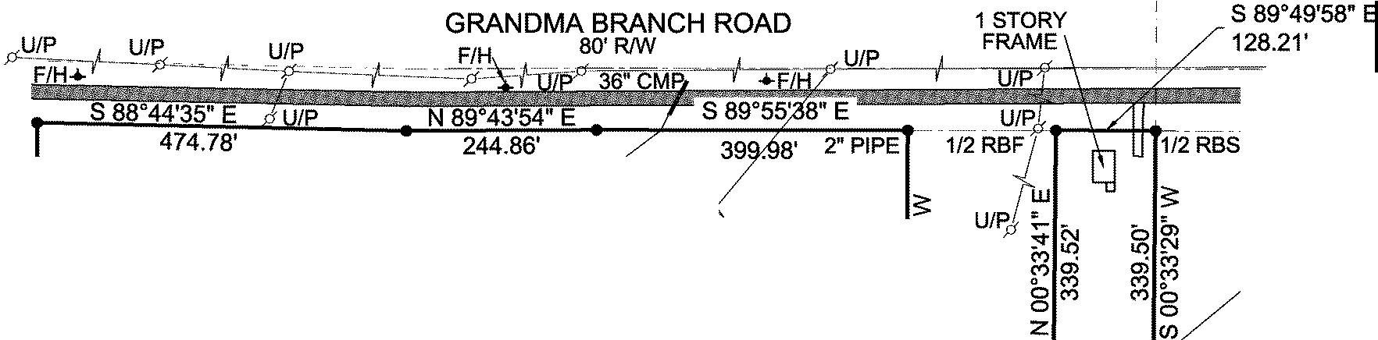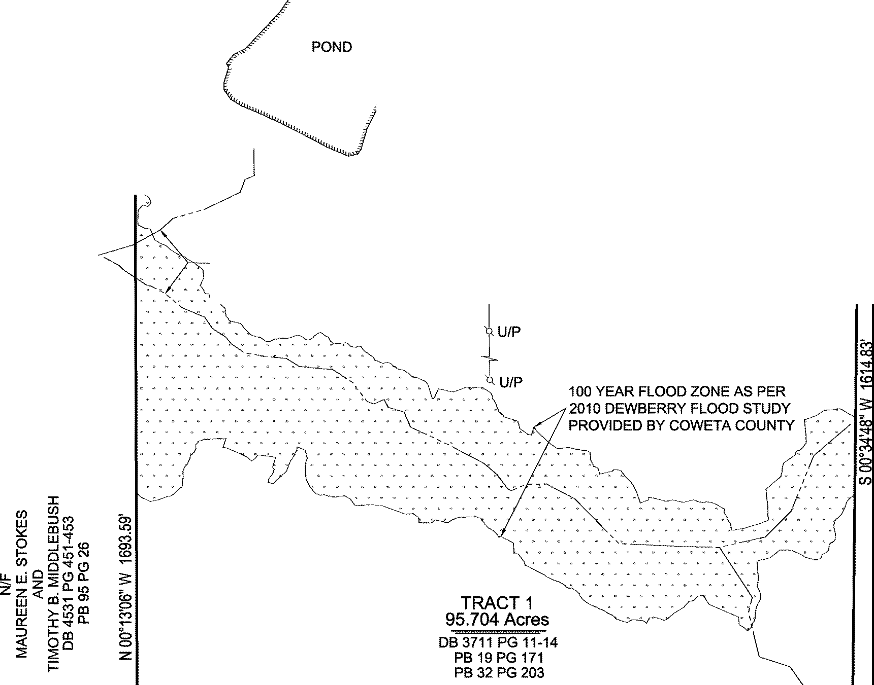1"ROD
7257735799
PARTICIPANT ID
BK:98 PG:215-215 P2020000043 FILED IN OFFICE
CLERK OF COURT
02/06/2020 12:56 PM CINDY BROWN, CLERK SUPERIOR COURT COWETA COUNTY, GA
THIS BLO
(\ J.
3
OF THE SUPERIOR COURT.

<O
et: ^{<O} co

,
,
,

1'I
o0, M. • (")
N
(0 0

TRACT2
0.999Acres

DB 3192 PG36
LEGEND RBF=REBAR FOUND RBS=REBAR SET
CTP=CRIMP TOP PIPE L.L.=LAND LOT
L.L.L.=LAND LOT LINE
fl. =PROPERTY LINE
CO=CONSTRUCTION ENTRANCE EP= EDGE OF PAVEMENT P.O.B.=POINT OF BEGINNING B/L=BUILDING SETBACK LINE D.E.=DRAINAGE EASEMENT N/F=NOW OR FORMERLY
F.W.P.D.=FIELD WORK PERFORMED DATE O/F=OUT OF FLOOD PLAIN DB=DEED BOOK
PG=PAGE PB=PLAT BOOK
@=HOUSE NUMBER

SURVEYORS CERTIFICATION:
Ww<.l.j.>. d
et: '°
"'
(!) "'
LzL •
:s: (!)
C.

U/P

N/F ELLIS SMITH
(") 0
0
(/)
-------r"' -,

This plat is a retracement of an existing parcel or parcels of land and does not subdivide or create a new parcel or make any changes to any real property boundaries. The recording information of the documents, maps, plats, or other instruments which created the parcel or parcels are stated hereon. RECORDATION OF THIS PLAT DOES NOT IMPLY APPROVAL OF ANY LOCAL JURISDICTION, AVAILABILITY OF PERMITS, COMPLIANCE WITH LOCAL REGULATIONS OR REQUIREMENTS, OR SUITABILITY FOR ANY USE OR PURPOSE
OF THE LAND. Furthermore, the undersigned land surveyor certifies that this plat complies with the minimum technical standards for property surveys in Georgia as set forth in the rules and regulations of the Georgia Board of Registration for Professional Engineers and Land Surveyors and as set forth in O.C.G.A. Section 15-6-67.
FINAL SURVEYOR'S CERTIFICATE IT IS HEREBY CERTIFIED THAT THIS
PLAT IS TRUE AND CORRECT AND WAS
PREPARED FROM AN ACTUAL SURVEY OF THE PROPERTY MADE BY ME OR UNDER MY SUPERVISION; THAT ALL MONUMENTS SHOWN HEREON ACTUALLY EXIST OR ARE MARKED AS "FUTURE" AND THEIR LOCATION, SIZE, TYPE, AND MATERIAL ARE CORRECTLY SHOWN. THIS PLAT CONFORMS TO ALL REQUIREMENTS OF THE GEORGIA PLAT ACT (O.C. .A. SECTION 15-6-67).
(Llil--
BY: SWINSON A. GASKINS, Sr. GEORGIA REGISTERED LAND SURVEYOR NO.1620 DATE: 01/31/20
Zw'"°' ,_
.w.J <0 ? 0
0g
J: OCJl z

1"ROD

CREEK

POND
DB 3693 PG 875-877 1
2" PIPE 6-
BENT If:' Q:-
N 89°54'55" E if
95.60' :_ "'
N 76°48'57" E
96.67'
11/2 RBF

S 89°50'42" E
128.23'

N/F
CITY OF GRANTVILLE

- ---
2"PIPE

@

1" PIPE
·-·-
@

@
en - ----
0

IVY GLEN

0 @
"2

1/2" RBF ON LINE
0 UNIT THREE
c..> @ PB 75 PG 242-245
m

N/F
BILLY LEE TUCKER DB 3208 PG 453 PB84 PG72
b....
:g
(0

1/2" RBF ON LINE
·-·-·-
@
@
·-·-·-

(LL\

FLOOD STATEMENT ACCORDING TO FEMA FLOOD
INSURANCE RATE MAP OF COWETA COUNTY AND UNINCORPORATED AREAS DATED FEBRUARY 6, 2013 MAP NUMBER 13077C0351 D, NO PORTION OF THIS PROPERTY LIES WITHIN A SPECIAL FLOOD HAZARD AREA

GRID NORTH
GA WEST ZONE NAD 83
FLAT IRON
ON LINE N 89°34'55" W 1429.67'
1/2"RBS..,_-,---;-----1r--.,---...---..:.:..:: :..,...:.: ---,.--,----,------
(@ I @ I @ @ I @, @ @ I @) I @ I @ I @ I @ @ / @ ¹¹¹²
I
CALICO CORNERS PHASE TWO

"RBS

CLOSURE STATEMENT
THE FIELD DATA UPON WHICH THIS PLAT IS BASED HAS A CLOSURE PRECISION OF ONE FOOT IN 42,167 FEET AND AN ANGULAR ERROR OF 00" 00' 02" PER ANGLE POINT AND HAS BEEN ADJUSTED USING THE COMPASS RULE METHOD.

THIS PLAT HAS BEEN CALCULATED FOR

GRAPHIC SCALE 1"=200'
PB 76 PG229

(LL\
CLOSURE AND IS FOUND TO BE ACCURATE
WITHIN ONE FOOT IN 100,000+ FEET.

ANGULAR & LINEAR MEASUREMENTS WERE OBTAINED USING A LIECA 403 TCR TOTAL STATION

/
Prepared For:
Job No. 18-060
Drawn By: lReviewed By:
R.D.G. R.M.B.
Issue Date: 01/31/20
F.W.P,D.: 01/27/20
Revisions Date
\

'

APEX KANDIS HOLDINGS, LLC

Property Location

Land Lot 242 Of The 2nd Land District Coweta County, Georgia

S.A. GASKINS &
ASSOCIATES, LLC
surveyors planners development consultants
P.O. BOX 303 BROOKS, GA 30205
678-571-3054
rdgaskins79@gmail.com

Coweta Co.
H
A
HOVEY & ASSOCIATES INC.
ENGINEERING CONSULTANTS 130 HOWARD LANE SUITE B FAYETTEVILLE, GA 30214
PHONE: 770-460-2200

INTERSTATE
85
27
PRELIMINARY PLAT
FOR GREYLAND FARMS
SUBDIVISION COWETA COUNTY, GEORGIA

PROJECT NO. 202200026

SITE

16

INTERSTATE
85 14

INDEX OF DRAWINGS

CIVIL

C1.1 COVER SHEET
C1.2 GENERAL NOTES / LEGEND / ABBREVIATIONS C1.3 OVERALL SITE PLAN
C1.4 SITE PLAN
C1.5 SITE PLAN

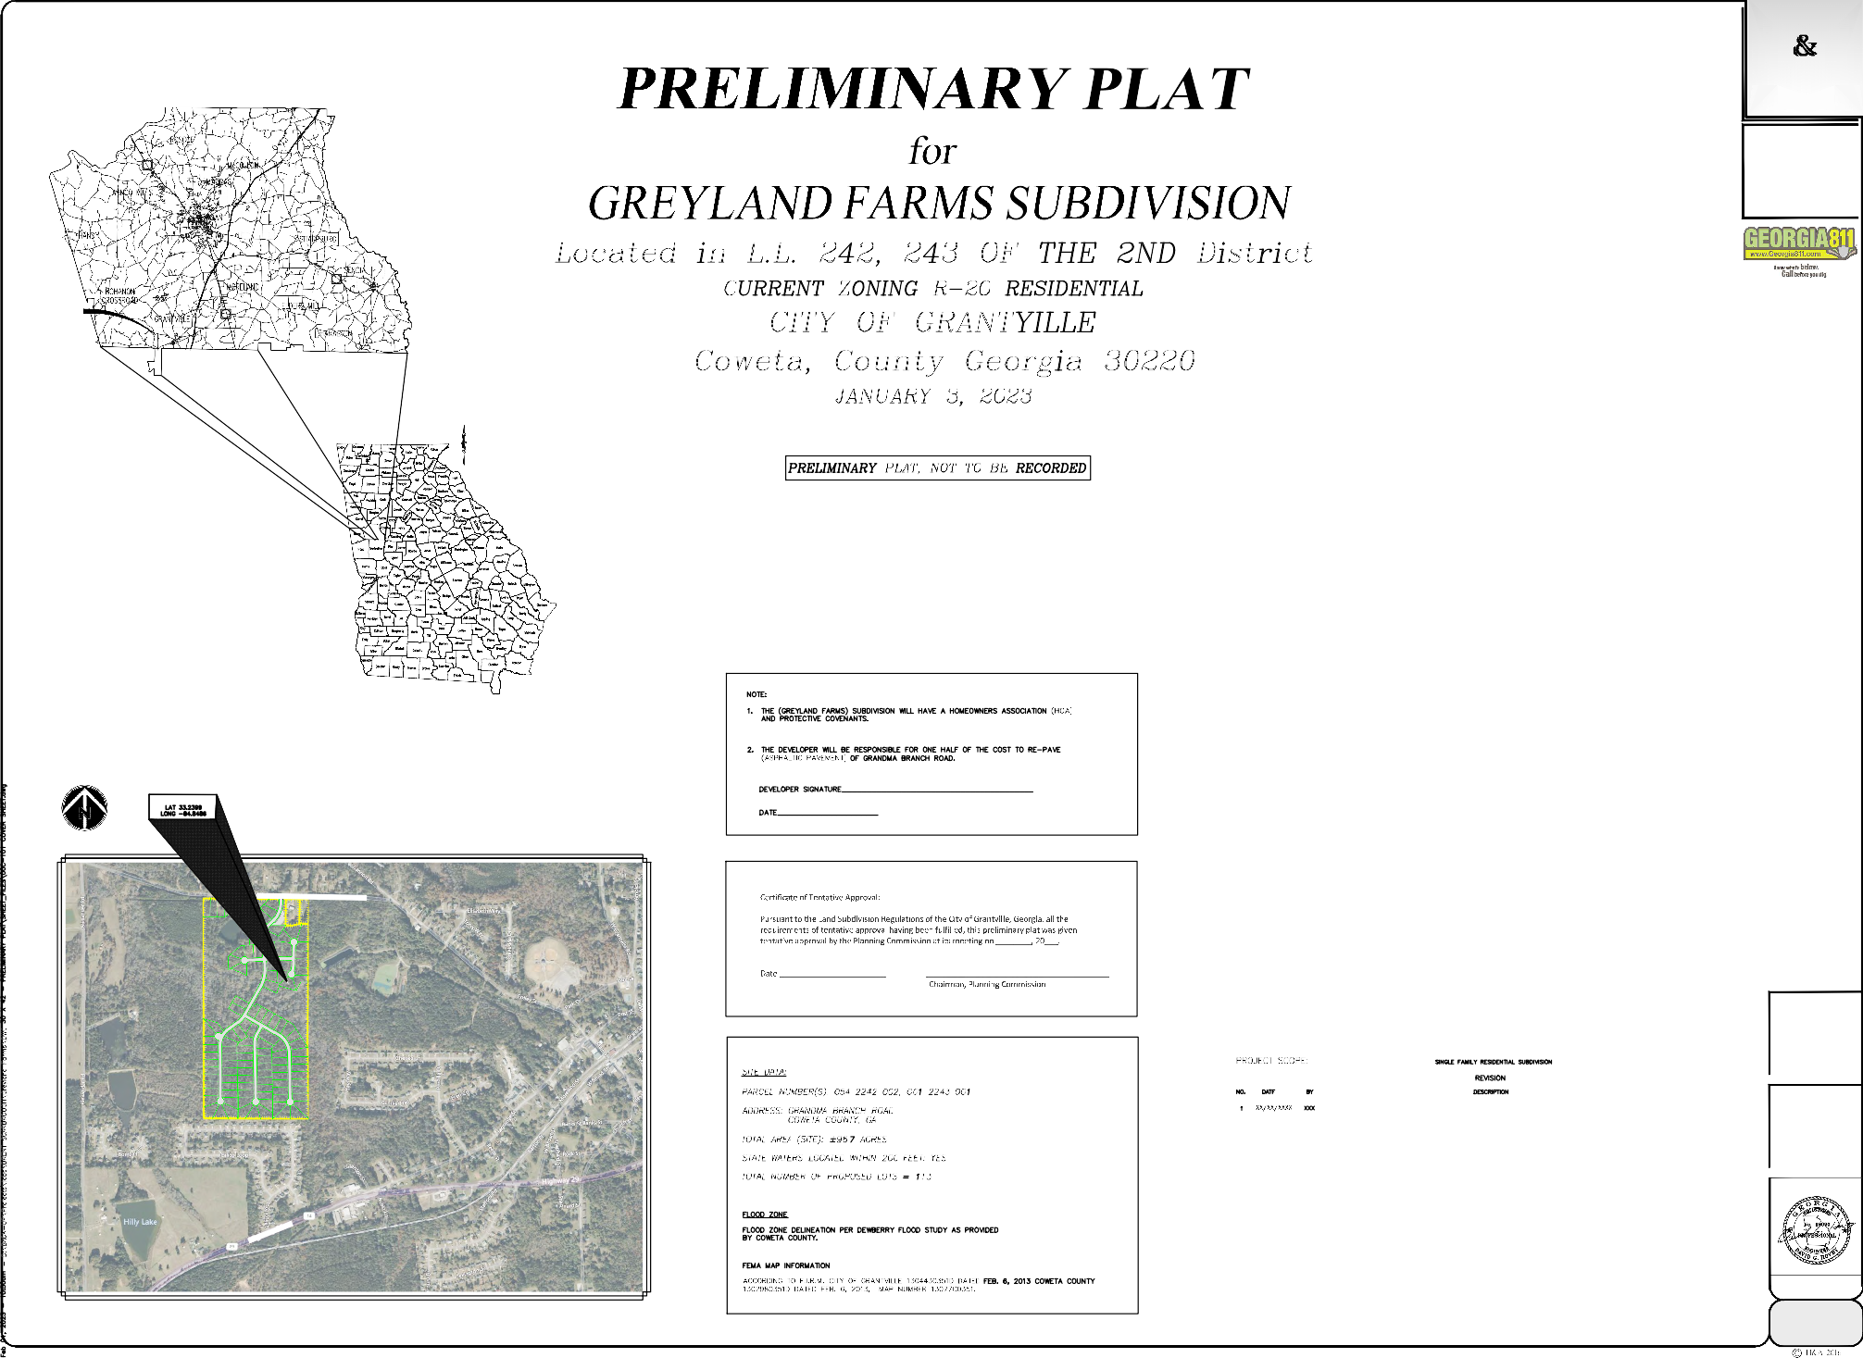

NORTH
SITE LOCATION

VICINITY MAP
N.T.S.
OWNER / DEVELOPER 24 HOUR CONTACT

COWETA GRANDMA BRANCH, LLC

270 N. JEFF DAVIS DRIVE FAYETTEVILLE, GA 30214

24 HOUR CONTACT: NAME: RICHARD FERRY PHONE: 770-461-0478
rferry@brentholdings.net

Pursuant to the Land Subdivision Regulations of the City of Grantville, Georgia, all the requirements of tentative approval having been fulfilled, this preliminary plat was given tentative approval by the Planning Commission at its meeting on
, 20 .
Date: | Secretary, Planning Commission

HOVEY & ACCOCIATES, INC.
LIC. #PEF003647 ACTIVE

SHEET

C1.1

0 2 4
6 8 10
12 14
16 18 20
22 24
26 28
30 32 34
36 38

H
A

HOVEY & ASSOCIATES INC.
ENGINEERING CONSULTANTS 130 HOWARD LANE SUITE B FAYETTEVILLE, GA 30214
PHONE: 770-460-2200

OWNER / DEVELOPER 24 HOUR CONTACT
COWETA GRANDMA BRANCH, LLC
270 N. JEFF DAVIS FAYETTEVILLE, GA 30214
24 HOUR CONTACT: RICHARD FERRY PHONE: 770-461-0478
rferry@brentholdings.ney

HOVEY & ACCOCIATES, INC.
LIC. #PEF003647 ACTIVE

CuC

PfD
DESCRIPTION
PuE

SCALE: HORZ.
VERT.

DRAWN BY:
NO.
DATE
7

6
5
4

3
2

1
J. FINNEY
DESIGNED BY:
D. HOVEY
CHECKED BY:
D. HOVEY
ISSUE DATE
01/03/2023
PROJECT NUMBER
20220026

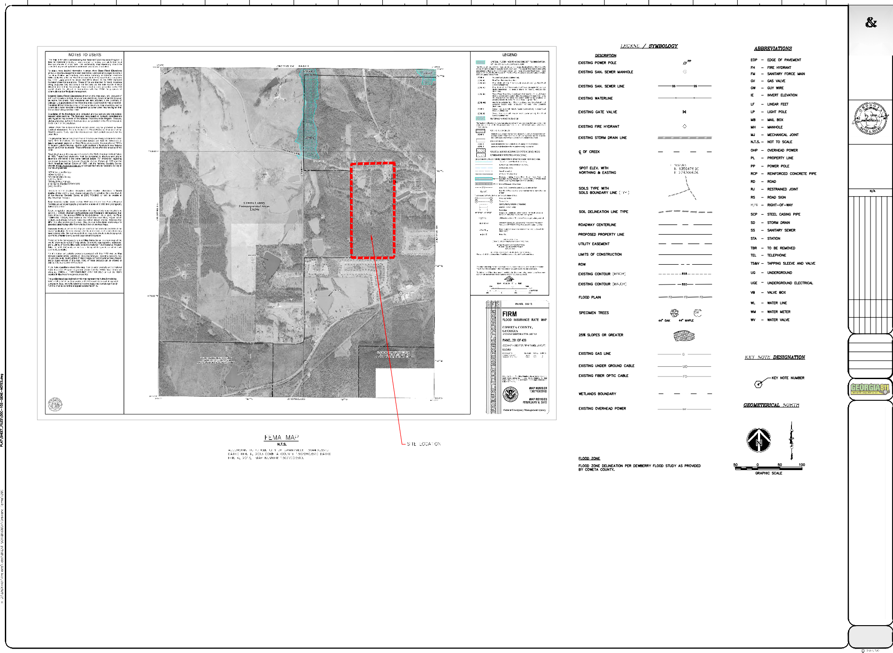* PRELIMINARY PLAT ~ NOT TO BE RECORDED *
PRELIMINARY PLAT
FOR
GREYLAND FARMS SUBDIVISION GRANTVILLE LANDLOT 242, 243 OF THE 2ND DISTRICT
CITY OF GRANTVILLE COWETA, COUNTY GEORGIA
GENERAL NOTES / LEGEND / ABBREVIATIONS

SHEET

C1.2

0 2 4
6 8 10
12 14 16

∆
18 20
22 24
26 28
30 32 34
36 38

H
A

HOVEY & ASSOCIATES INC.
ENGINEERING CONSULTANTS 130 HOWARD LANE SUITE B FAYETTEVILLE, GA 30214
PHONE: 770-460-2200

OWNER / DEVELOPER 24 HOUR CONTACT
COWETA GRANDMA BRANCH, LLC
270 N. JEFF DAVIS FAYETTEVILLE, GA 30214
24 HOUR CONTACT: RICHARD FERRY PHONE: 770-461-0478
rferry@brentholdings.ney

HOVEY & ACCOCIATES, INC.
LIC. #PEF003647 ACTIVE

SCALE: HORZ.
VERT.

RK
RK

CeC

CeD CeD

RK CfD2 CfD2

CfD2
CfD2
DESCRIPTION

CfD2

CfD2

CfD2
DATE

OPEN SPACE

CfD2

CeC CeC
NO.
7

6
5
4

3
2

1

OPEN SPACE

CeC

CeC

CfD2

CfD2
C6

RK

RK

CeC

PhE3

PhE3

DRAWN BY:
J. FINNEY
DESIGNED BY:
D. HOVEY
CHECKED BY:
D. HOVEY
ISSUE DATE
01/03/2023
PROJECT NUMBER
20220026

CfD2

CeC

PhE3

OPEN SPACE
RK

CeC

RK

RK
CfD2

CeC
PRELIMINARY PLAT
FOR
GREYLAND FARMS SUBDIVISION GRANTVILLE LANDLOT 242, 243 OF THE 2ND DISTRICT
CITY OF GRANTVILLE COWETA, COUNTY GEORGIA
OVERALL SITE PLAN

CfD2
PhE3

CfD2

RK

RK CeC

PhE3

CeC

OPEN SPACE

COLLEY COURT

CfC2
CfD2

CeC

CeC

CeC

OPEN SPACE

RK RK

MdE

MdE

MdE

PhE3

CeC

CeC

CfC2

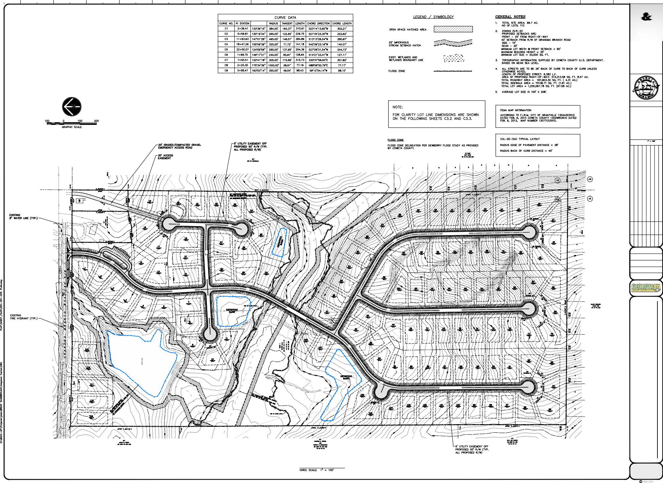OVERALL SITE PLAN

SHEET

C1.3

0 2 4
6 8 10
12 14
16 18 20
22 24
26 28
30 32 34
36 38

H
A

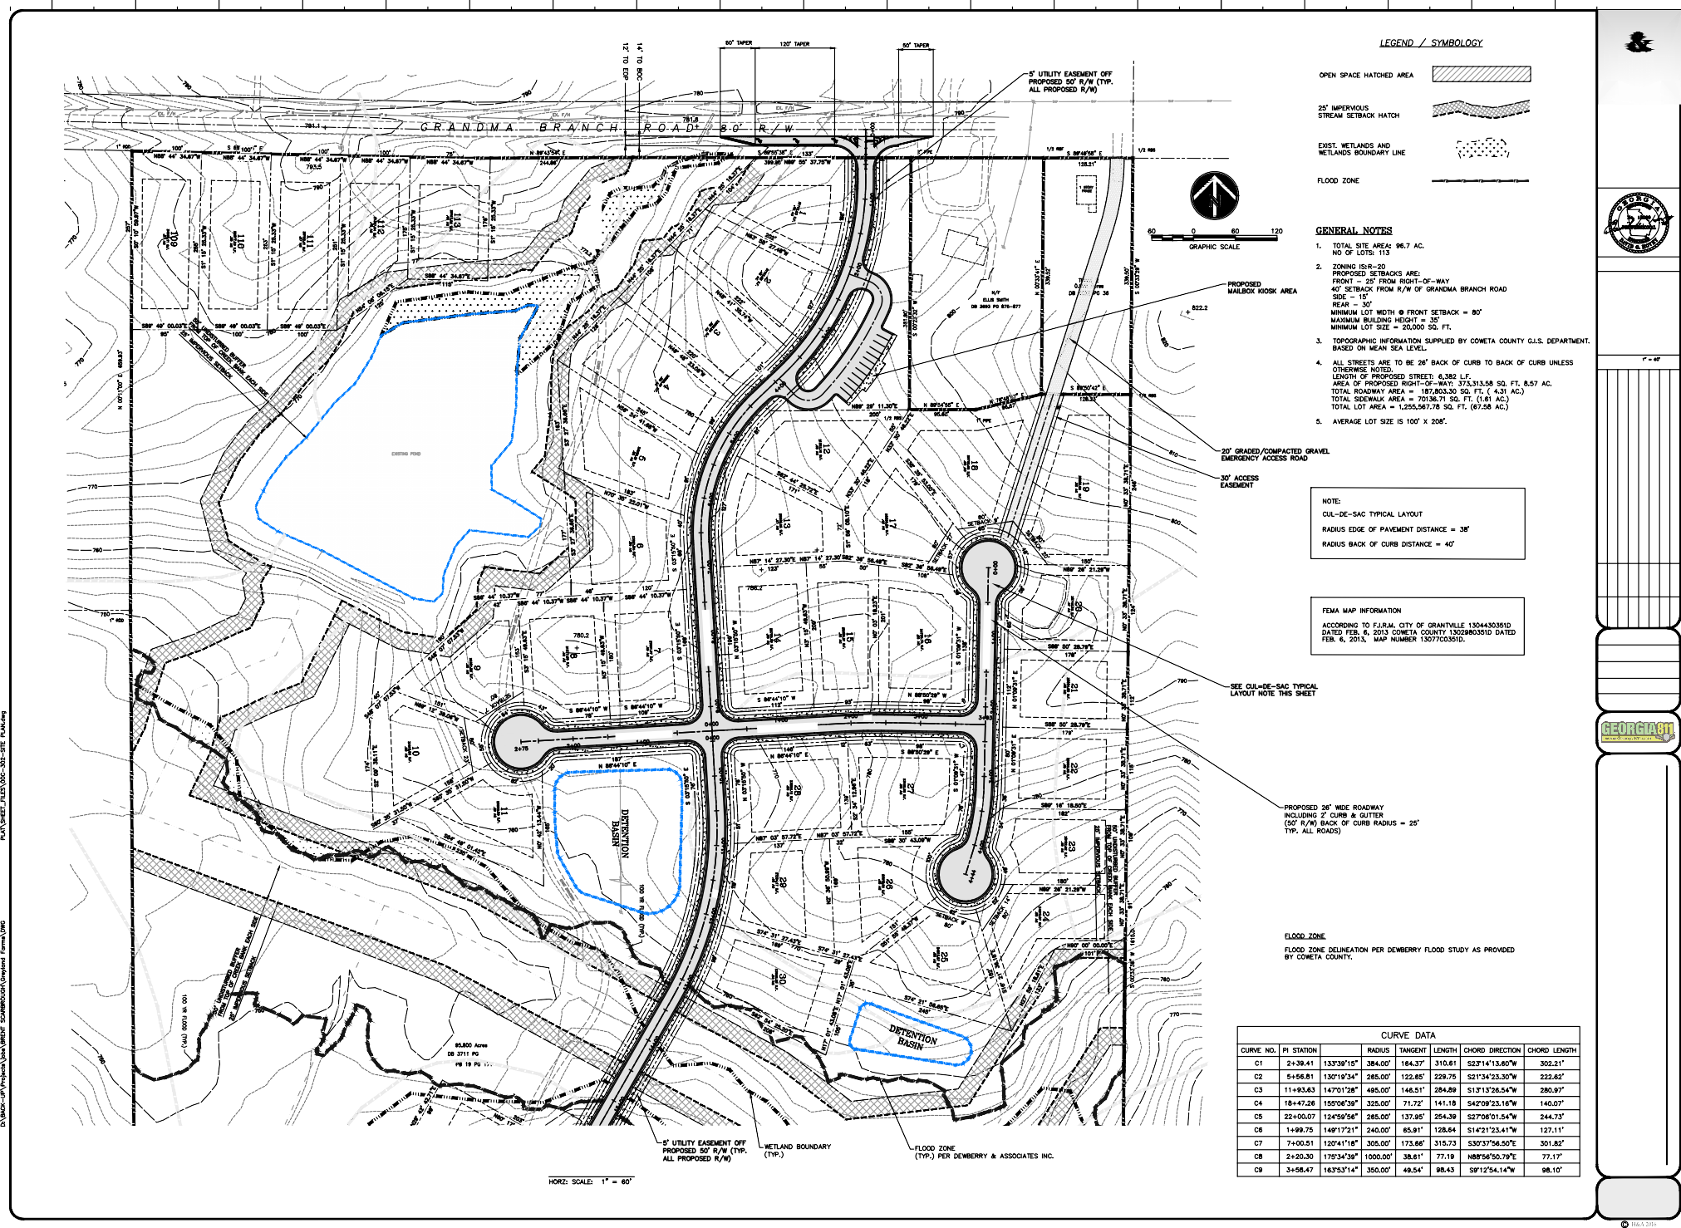HOVEY & ASSOCIATES INC.
CeC
CeC
CeC
RK
ENGINEERING CONSULTANTS 130 HOWARD LANE SUITE B FAYETTEVILLE, GA 30214
PHONE: 770-460-2200

OWNER / DEVELOPER 24 HOUR CONTACT
COWETA GRANDMA BRANCH, LLC
270 N. JEFF DAVIS FAYETTEVILLE, GA 30214
24 HOUR CONTACT: RICHARD FERRY PHONE: 770-461-0478
CeC
rferry@brentholdings.ney
CeC
OPEN SPACE
RK
RK
CfD2

HOVEY & ACCOCIATES, INC.
OPEN SPACE
CeC
LIC. #PEF003647 ACTIVE
RK

SCALE: HORZ.
RK
VERT.
CeC
CeC
DESCRIPTION

DRAWN BY:
RK
NO.
DATE
7

6
5
4

3
2

1
J. FINNEY
DESIGNED BY:
D. HOVEY
CHECKED BY:
D. HOVEY
ISSUE DATE
CeD
01/03/2023
PROJECT NUMBER
CfD2
20220026
CeD
CfD2
CfD2
CeC

∆
RK
RK
CfD2
RK
CfD2
CeC
RK
OPEN SPA
OPEN SPACE
MdE
PRELIMINARY PLAT
FOR
GREYLAND FARMS SUBDIVISION GRANTVILLE LANDLOT 242, 243 OF THE 2ND DISTRICT
CITY OF GRANTVILLE COWETA, COUNTY GEORGIA
SITE PLAN

SITE PLAN
CfD2

SHEET

C1.4

0 2 4
RK
6 8 10
12 14
16 18 20
22 24
26 28
30 32 34
36 38

H
A
CfD2
OPEN SPACE
MdE

HOVEY & ASSOCIATES INC.
ENGINEERING CONSULTANTS 130 HOWARD LANE SUITE B FAYETTEVILLE, GA 30214
OPEN SPACE
PHONE: 770-460-2200

OWNER / DEVELOPER 24 HOUR CONTACT
CfD2
COWETA GRANDMA BRANCH, LLC
270 N. JEFF DAVIS FAYETTEVILLE, GA 30214
24 HOUR CONTACT: RICHARD FERRY PHONE: 770-461-0478
rferry@brentholdings.ney
CfD2
RK
MdE

HOVEY & ACCOCIATES, INC.
LIC. #PEF003647 ACTIVE
CfD2

SCALE: HORZ.
VERT.
CfD2
CfD2
MdE
DESCRIPTION

DRAWN BY:
PhE3
PhE3
PhE3
NO.
DATE
7

6
5
4

3
2

1
J. FINNEY
CfD2
DESIGNED BY:
CeC
D. HOVEY
CHECKED BY:
COLLEY COURT
D. HOVEY
ISSUE DATE
01/03/2023
PROJECT NUMBER
20220026

∆
CfD2
CeC
PhE3
PhE3
PRELIMINARY PLAT
FOR
GREYLAND FARMS SUBDIVISION GRANTVILLE LANDLOT 242, 243 OF THE 2ND DISTRICT
CITY OF GRANTVILLE COWETA, COUNTY GEORGIA
SITE PLAN

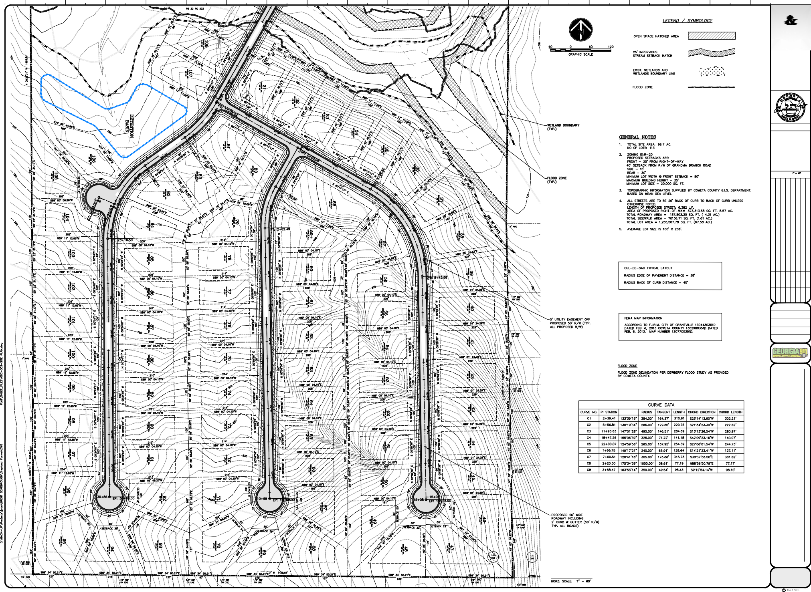SITE PLAN
CfD2
CeC
PhE3
CeC
CeC
CfC2
CeC
SHEET

C1.5

Brennan Jones Engineering
Associates, LLC

Technical Memorandum
To: Mr. Al Grieshaber, Jr., City Manager City of Grantville, Georgia
From: Brennan D. Jones, P.E.
CC:
Date: January 25, 2023
Re: Water System Capital Improvement Plan BJEA Project No. 08004.31

Background
The City of Grantville water system was originally constructed prior to 1930 and the water system has been expanded and improved on multiple occasions since that time. The original water system was supplied by groundwater wells, which operated until the early 1990s. The water system discontinued use of the original water supply wells because groundwater contamination was found in the wells. At that time, Grantville connected its water system to Coweta County Water System to purchase potable water from the County. The water system currently serves approximately 2,300 mostly residential customers and the current water use is approximately 210,000 gallons per day. Grantville Water System includes approximately thirty (30) miles of water main and two elevated steel water storage tanks (i.e., City Hall Tank 100,000 Gal and Brown School Tank 200,000 Gal).
The Grantville connection point with Coweta County Water and Sewer Authority (CCWSA) is located at the eastern end of the City near the intersection of Bexley Road at US Hwy 29/SR 14. The City also has two other back-up connections to CCWSA lines for back-up water supply in the event of an emergency. The water system has been experiencing problems maintaining Total Trihalomethanes (TTHM) levels below the US EPA required Mean Concentration Level (MCL) of 80 micrograms per liter (i.e., 80 parts per billion), at the western extremity of the water system. In addition, concentration of TTHM nearing the MCL have been observed in the City Hall water storage tank. Testing for TTHM is on-going throughout the water system to determine locations where TTHM levels may be elevated.
The City of Grantville recognizes that an essential element in maintaining community vitality and good public health is the availability of sufficient potable water facilities. Water supply facilities should provide water that is safe, and the water storage and delivery systems should be reliable, efficient and have capacity to support anticipated future growth of the community. Grantville is aware that its existing water system needs improvements and needs to be expanded to serve the community. Both short-term and long-term improvements will be necessary.
The City retained Brennan Jones Engineering Associates, LLC to prepare a water system Capital Improvement Plan (CIP) to address:
- Water Quality issues including Total Trihalomethanes (TTHM) formation.
- Water System Looping.
- Water Supply for Fire Protection.
- Water system needs to support future residential, commercial, and industrial development.

Page 1

Technical Memorandum
Water System Capital Improvement Plan January 25, 2023

Summarized below are capital improvement projects to provide water quality improvements and to support development within the City of Grantville. The map that accompanies this memorandum shows locations of the project described below.
Water System Capital Improvement Plan
- Water System Hydraulic Network Model
A water system hydraulic network model will provide an engineering tool to allow for evaluation of the existing water system and for planning of future improvements. The water system model will enable the City to evaluate domestic water usage patterns, evaluate fire flow capability, evaluate water quality, and water age. A water system network model is necessary to allow for proper planning of water system improvements.
Estimated Cost: $55,000
- THM Removal Systems for Existing Elevated Water Storage Tanks
To reduce water system Total Trihalomethanes (TTHM) levels, TTHM removal system are recommended to be installed at existing water storage tanks. TTHM removal systems shall be a technically proven water treatment system involving active mixing and ventilation of existing water storage tanks. For TTHM removal, spray, and surface aeration systems available. System has spray nozzles and pumps OR surface aerators which provide water surface area for mass transfer, active headspace ventilation systems which evacuate TTHM laden air from the headspace of the tank, and mixers which continually refresh the mass transfer zone at the water surface. Systems are sized to deliver a specific % reduction in TTHM from 20% to 70%.
Estimated Cost: $275,000
Source: PAX Water Technologies, and Viking Construction Management, Inc.
- Raise Existing 200,000-Gallon Brown School Elevated Water Storage Tank
Raise the water storage tank overflow elevation by approximately 10 feet to match the elevation of the 100,000-Gal City Hall water storage tank. Raising the water tank elevation will allow the Brown School water tank to properly cycle; thereby, improving water quality and reducing TTHM formation probability.
Estimated Cost: $250,000
Source: Ed Jackson, R. E. McLean Tank Company, Inc.
- New 500,000-Gallon Elevated Water Storage Tank w/ THM Removal System
The water storage tank will provide water storage for fire protection for nearby planned industrial development and allow for residential and commercial development growth in the US Hwy 29/SR 14 corridor.
Multi-leg Elevated Steel Water Storage Tank, Estimated Cost: $1,850,000
Composite (Concrete Pedestal / Steel Container) Elevated Water Tank, Estimated Cost: $2,700,000 Source: E. Monske, Caldwell Tanks, Inc.
- Water System Looping Projects
  - 12-inch diameter loop US Hwy 29/SR 14 – Clarence McCambry Rd to Lone Oak Rd
7,100 LF 12-inch water main is needed to support new development of the US Hwy 29/SR 14 corridor including industrial, commercial, and residential developments. The water main also provides looping of the water system, which will improve fire protection, reliability, redundancy, and water quality.

Brennan Jones Engineering Page 2
Associates, LLC

Technical Memorandum
Water System Capital Improvement Plan January 25, 2023

Estimated Cost: $850,000 Source: Engineer’s Estimate
  - 8-inch diameter loop at US Hwy 29/SR 14 to Brasch Park Subdivision
270 LF 8-inch water main loop from south side of Hwy 29 water main to Brasch Park subdivision. The water main provides looping of the water system, which will improve fire protection, reliability, redundancy, and water quality.
Estimated Cost: $67,000 Source: Engineer’s Estimate
  - 8-inch diameter loop through Planned Greyland Farms Subdivision
3,500 LF 8-inch water main loop through the planned Greyland Farms subdivision from Grandma Branch Road to Ivy Glen subdivision. The water main provides looping of the water system, which will improve fire protection, reliability, redundancy, and water quality.
Estimated Cost: $300,000 (Cost will be offset by developer contribution/construction of water main within the subdivision.)
Source: Engineer’s Estimate
  - 8-inch diameter loop Calico Corners Subdivision to Breckenridge Subdivision
570 LF 8-inch water main loop from Calico Corners subdivision to Breckenridge subdivision. The water main provides looping of the water system, which will improve fire protection, reliability, redundancy, and water quality.
Estimated Cost: $51,000 Source: Engineer’s Estimate
  - 12-inch diameter loop and extension US Hwy 29/SR 14 – Lone Oak Rd to Minnie Sewell Rd
14,500 LF 12-inch water main is needed to support new development of the western portion of the City along US Hwy 29/SR 14 to Minnie Sewell Road. This project would extend the water system to serve incorporated areas in Grantville that presently does not have potable water service or fire protection.
Development in the corridor includes industrial, commercial, and residential developments. The water main provides extension and looping of the water system, which will improve fire protection, reliability, redundancy, and water quality.
Estimated Cost: $1,740,000 Source: Engineer’s Estimate
  - 8-inch diameter loop at US Hwy 29/SR 14 to Coweta Heard Rd
100 LF 8-inch water main loop from south side of Hwy 29 water main to Coweta Heard Rd. The water main provides looping of the water system, which will improve fire protection, reliability, redundancy, and water quality.
Estimated Cost: $30,000 Source: Engineer’s Estimate
  - 8-inch diameter loop at US Hwy 29/SR 14 to Calico Corners subdivision

Brennan Jones Engineering Page 3
Associates, LLC

Technical Memorandum
Water System Capital Improvement Plan January 25, 2023

100 LF 8-inch water main loop from south side of Hwy 29 water main to Calico Corners subdivision. The water main provides looping of the water system, which will improve fire protection, reliability, redundancy, and water quality.
Estimated Cost: $30,000 Source: Engineer’s Estimate
  - 8-inch diameter loop at US Hwy 29/SR 14 to LaGrange Street
250 LF 8-inch water main loop from south side of Hwy 29 water main to LaGrange Street. The water main provides looping of the water system, which will improve fire protection, reliability, redundancy, and water quality.
Estimated Cost: $45,000 Source: Engineer’s Estimate
- Fire Hydrant Replacement and Valve Installation
Replacement of approximately fifty (50) fire hydrants that have reached service life is needed to improve fire protection reliability of the water system. In addition, water valve installation to replace valves that have reached service life is needed in approximately fifty (50) locations to improve system reliability.
Estimated Cost: $400,000 Source: Engineer’s Estimate

Summary of Project Costs
Cost Description

$55,000 | A. Water System Hydraulic Network Model
$275,000 | B. THM Removal Systems for Existing Elevated Water Storage Tanks
$250,000 | C. Raise Existing 200,000-Gallon Brown School Elevated Water Storage Tank
$2,700,000 | D. New 500,000-Gallon Elevated Water Storage Tank w/ THM Removal System
$3,113,000 | E. (1-8) Water System Looping and Extension Projects
$400,000 | F. Fire Hydrant Replacement and Valve Installation
$6,793,000 | Total

Financing Capital Projects
Various sources and methods are available to the City for financing the construction cost for water system capital improvement projects. Listed below are methods for financing projects:
- Water System Enterprise Fund System Operating Reserves
- SPLOST
- General Funds
- Loans from Sources such as GEFA (Georgia Fund and Drinking Water State Revolving Fund), USDA Loan, etc.
- Development Agreements including capital contributions from developers.
- General Obligation Bonds, Special Assessment Bonds and Revenue Bonds

Brennan Jones Engineering Page 4
Associates, LLC

Technical Memorandum
Water System Capital Improvement Plan January 25, 2023

- Georgia Department of Community Affairs (DCA) (Community Development Block Grant (CDBG), Economic Development Financing Packet, One Georgia Authority (Equity Fund)
- Economic Development Administration (EDA), Department of Commerce
If loans or bonds are used for financing capital improvements, the City will be required to qualify for the debt and will be required to maintain certain levels of debt service coverages. This may require the City to increase water rates on its customer base to ensure that financial obligations can be achieved. In cases of grant or partial grant funding, the City is typically required to contribute 10% or more towards the total project cost to qualify for funding. It is noted that grant funding is often difficult to obtain due to competition for this funding source.
General Assumptions and Considerations
In the preparation of this study and cost projections, certain assumptions have been made with respect to conditions that may occur in the future. While it is believed that these assumptions are reasonable for the purpose of the study, they are dependent upon future events and actual conditions that may differ from those assumed. In addition, this study used and relied upon certain information provided by others. This information includes, among other things, estimated construction costs (FY2022), and other information and data provided by contractors and process equipment manufacturer representatives. While these sources are believed to be reliable, there has been no independent verification of the information and no assurances are offered with respect thereto. To the extent that future conditions differ from those assumed herein, the actual costs may vary from those predicted in the study.

END OF MEMORANDUM

Brennan Jones Engineering Page 5
Associates, LLC

Back-up Water Connection from CCWSA

GRANTVILLE WATER SYSTEM CAPITAL IMPROVEMENT PLAN
City of Grantville, GA January 20, 2023

Back-up Water Connection from CCWSA

Primary Water Purchase Connection from CCWSA

(C) Raise Level of Brown School Water Tank

(B) Water Tank THM Removal System
I-85 On Ramp
Grandma Branch Rd
Lowery Rd

Planned Greyland Farms Subdivision
Arnold St Grady Smith St
Clarence McCambry Rd

(E-3) 8-inch DIP 3,500 LF
(B) Water Tank THM Removal System

(E-4) 8-inch DIP 570 LF

(D) 500,000 Gal Elevated Water StorageTank w/THM Removal System

Industrial Zoned Property

(E-6) 8-inch DIP 100 LF
Alexander Rd
(E-7) 8-inch DIP 100 LF

(E-8) 8-inch DIP 250 LF

Industrial Zoned Property
(E-2) 8-inch DIP 270 LF

(E-1) 12-inch DIP 7,100 LF

(E-5) 12-inch DIP 14,500 LF from Lone Oak Rd to Minnie Sewell Rd to serve Industrial zoned and residential zoned property
Legend
Proposed Water Tank
Proposed WaterLines
Linetype
8 inch
12 inch
WaterPoints
Water Tank Meter Pit
Fire Hydrant Valve
WaterLines
1.5 inch
2 inch
4 inch
6 inch
8 inch
10 inch

Residential Zoned Property

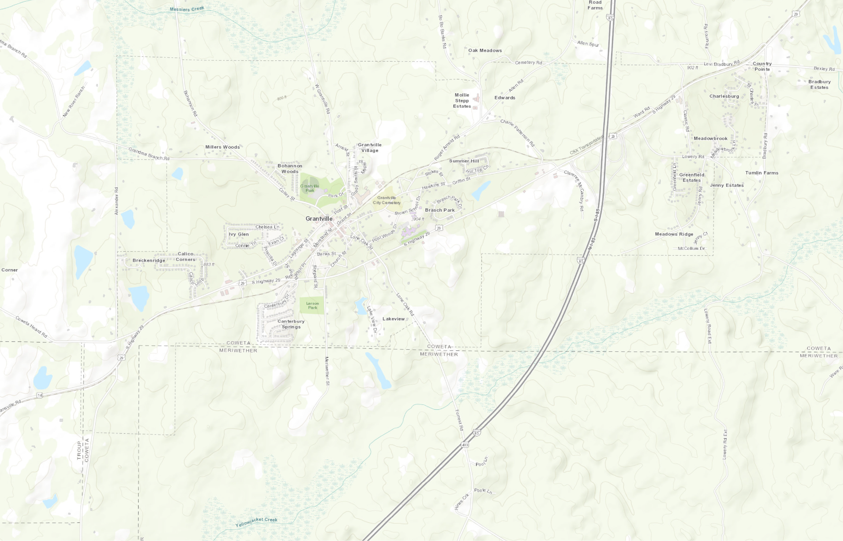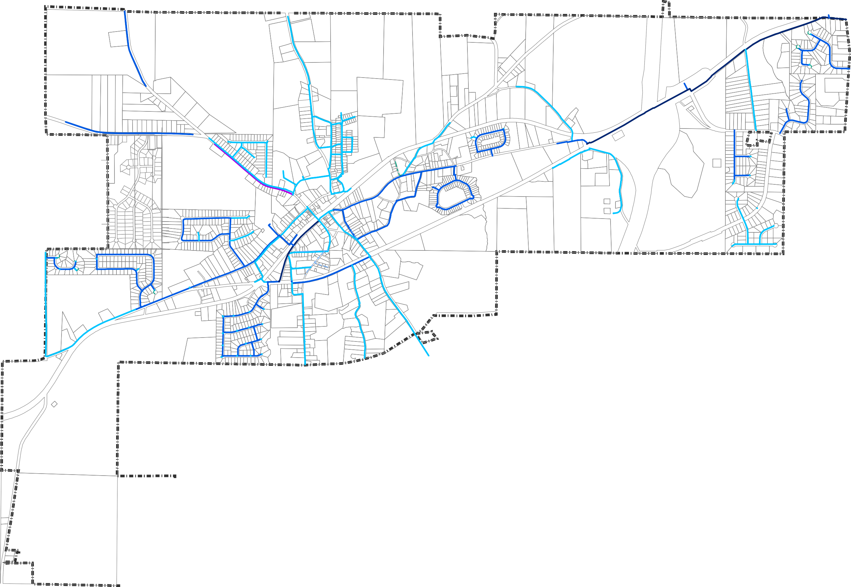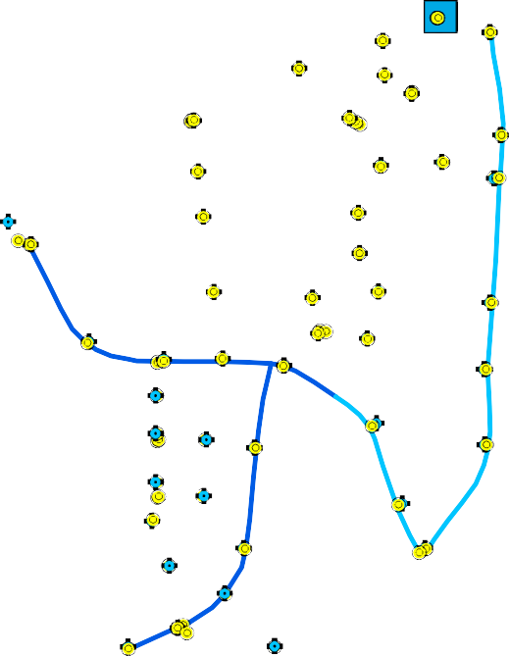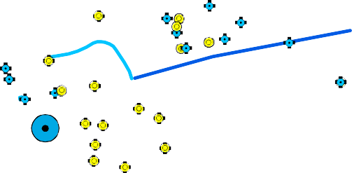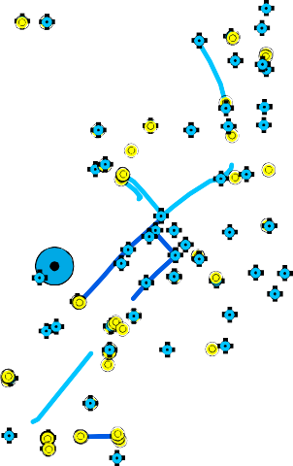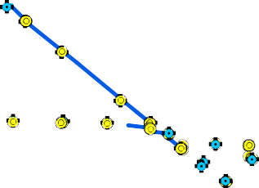
Sources: Esri, HERE, Garmin, Intermap, increment P Corp., GEBCO, USGS, FAO, NPS, NRCAN, GeoBase, IGN, Kadas Esri China (Hong Kong), (c) OpenStreetMap contributors, and the GIS User Community
ter NL, Ordnance Survey, Esri Japan, METI,
0 410 820 1,640 2,460 3,280

Feet

