AGENDA

Planning Commission Meeting July 7, 2022
6:00 p.m.

Meeting Location:
Grantville City Hall – Council Chambers 123 LaGrange Street
Grantville, GA 30220

Audio Conference Number: 425-436-6364 Access Code: 336977#

CALL TO ORDER ATTENDANCE
REVIEW & APPROVAL OF MINUTES

June 16, 2022 Planning Commission Meeting

REPORT OF COMMITTEES (if any) UNFINISHED BUSINESS

HEARING OF CASES NEW BUSINESS
Rezoning Application for Parcels G06-0002-008 – Holtzclaw Road at US Hwy 29, (0.73 Acres)
- Current Zoning – R20 Single Family Residential
- Current Land Use - Undeveloped
- Requested zoning district in Grantville – General Commercial (GC)
- Conceptual Site Plan exhibit prepared by Contineo Group

ADJOURNMENT

Page 1

Grantville Planning Commission Meeting Minutes

Date: March 16, 2022
Time: 6:00 p.m.
Location: Grantville City Hall, 123 LaGrange Street Grantville, Georgia 30220
and by Audio Conference Number: 425-436-6364 Access Code: 336977#

Mr. Ward, Vice Chairmen presided over the meeting because the Chairman attended by conference call.

Mr. Ward called the Planning Commission meeting to order at 6:00 p.m.

Attendance
Joe Ward, Vice Chairman
Tyree Raptis, Chairman (by conference call) Brenda Maddox (by conference call) Brennan Jones, Zoning Administrator

Public Attendance
Robi Higgins, City Clerk Dewayne Cook
Richard Proctor Kyle Willis

Review & Approval of Minutes
Adoption of Planning Commission Meeting Minutes from March 7, 2022
Planning Commission meeting minutes for the meeting held on March 7, 2022, were distributed to the members for review and adoption. After review of the minutes, a motion was made by Mrs.
Maddox to adopt the March 7, 2022, Planning Commission Meeting Minutes. The motion was seconded by Mr. Raptis. After discussion, Mr. Ward called for a vote and the motion passed unanimously.

Report of Committees
None

Unfinished Business
None

Hearing of Cases
None

Page 1 of 2

New Business
Final Plat for Minor Subdivision for parcel 054 2239 002 (10.59 Acres)
Mr. Jones presented the application for a minor subdivision of the parcel 054 2239 002. Mr. Raptis made a motion to recommend approval of the Final Plat for parcel 054 2239 002. The motion was seconded by Mrs. Maddox. After discussion, Mr. Ward called for a vote and the motion passed unanimously.

Adjournment
Mr. Raptis made a motion to adjourn the meeting. Mrs. Maddox seconded the motion. Mr. Ward adjourned the Planning Commission Meeting at 6:07 p.m.

Page 2 of 2

AGENDA

Planning Commission Meeting June 16, 2022
6:00 p.m.

Meeting Location:
Grantville City Hall – Council Chambers 123 LaGrange Street
Grantville, GA 30220

Audio Conference Number: 425-436-6364 Access Code: 336977#

CALL TO ORDER ATTENDANCE
REVIEW & APPROVAL OF MINUTES

March 7, 2022 Planning Commission Meeting REPORT OF COMMITTEES UNFINISHED BUSINESS

HEARING OF CASES NEW BUSINESS
Final Plat for Minor Subdivision for Parcel G06 0001 005A (33.27 Acres)
An application for a minor subdivision of the Parcel G06 0001 005A was submitted by the property owner. The property will be subdivided into two tracts Tract 1 (6.16 Acres) and Tract 2 (27.11 Acres). A mushroom farm is being proposed on the Tract 2 portion of the property.

ADJOURNMENT

Page 1

Coweta County, GA

Overview

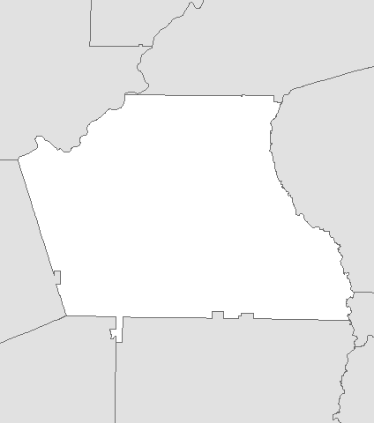
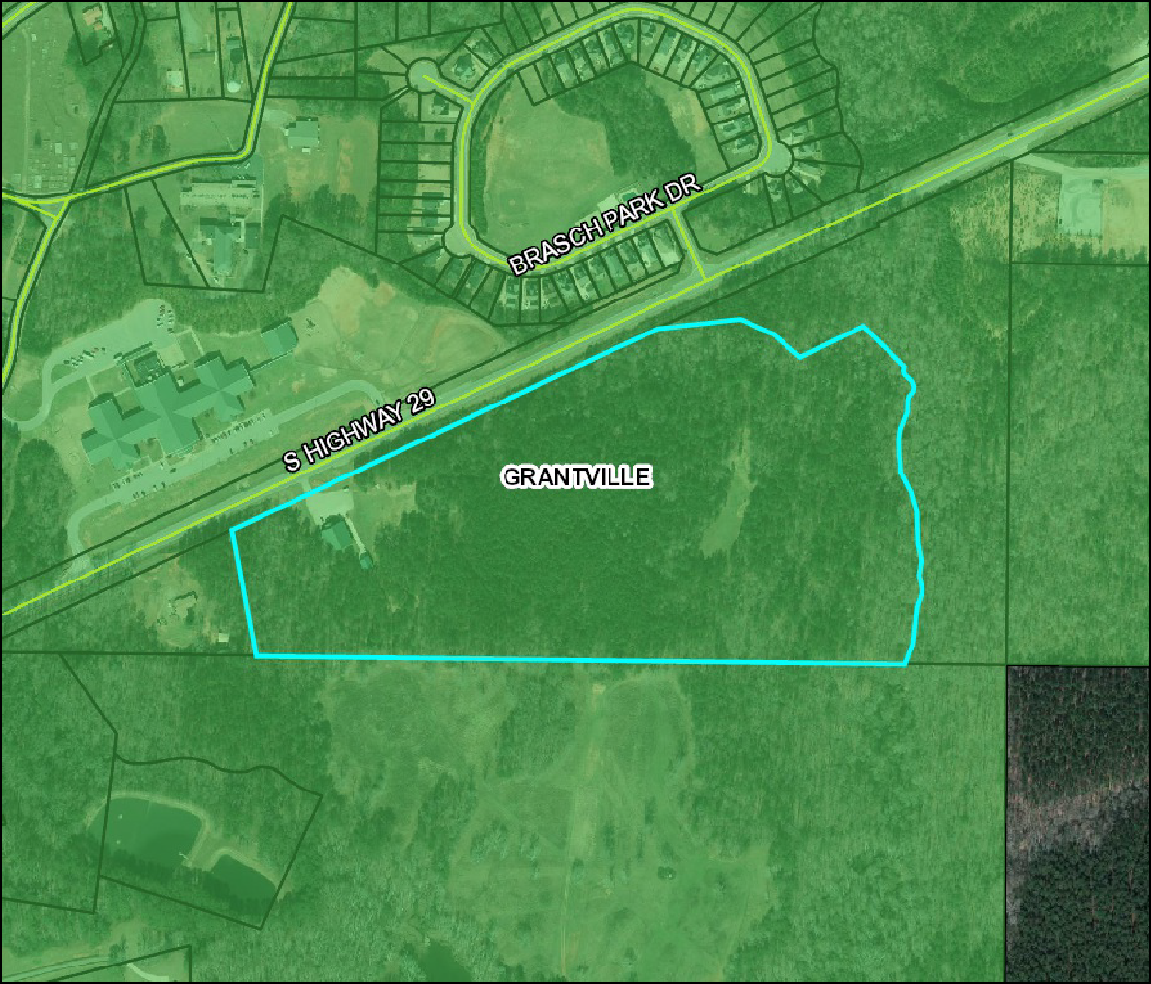Legend
528 ft

Parcels Roads Municipalities
CHATTAHOOCHE HILLS
GRANTVILLE HARALSON MORELAND NEWNAN PALMETTO SENOIA SHARPSBURG TURIN

Parcel ID | G06 0001 005A | Owner | COOK WILLIAM D | Last 2 Sales
Class Code | Residential |  | 5710 HIGHWAY 29 | Date Price | Reason | Qual
Taxing District | GRANTVILLE 04 |  | GRANTVILLE, GA 30220 | 3/2/2011 $165000 | 12 | U
Acres | 33.21 | Physical Address | 5710 S HIGHWAY 29 | 7/6/2010 $466202 | 16 | U
 |  | Assessed Value | Value $249360
(Note: Not to be used on legal documents)

Date created: 6/6/2022
Last Data Uploaded: 6/6/2022 12:40:21 AM Developed by

PROPERTY ADDRESS

VICINITY MAP
NOT TO SCALE

SITE
 |  |  |  |  |  | 6/3/22 | 5/26/22
 |  |  |  |  |  | ISSUED FOR PLATTING | ISSUED FOR REVIEW
 |  |  |  |  |  | 2. | 1.
 |  | LJS
DKW
5/24/22 |  | 1663.2201

5710 S. HIGHWAY 29
GRANTVILLE, GA

NOTES
- THIS PLAT WAS PREPARED FOR THE EXCLUSIVE USE OF THE PERSON, PERSONS, OR ENTITY NAMED IN THE TITLE BLOCK. SAID USE DOES NOT EXTEND TO ANY UNNAMED PERSON WITHOUT EXPRESS PERMISSION BY THE SURVEYOR NAMING SAID PERSON.

- THE PROJECT HORIZONTAL DATUM IS RELATIVE TO THE NORTH AMERICAN DATUM 1983 (NAD83), 2011 ADJUSTMENT, PROJECTED TO THE GEORGIA STATE PLANE COORDINATE SYSTEM, WEST ZONE. THE VERTICAL DATUM IS RELATIVE TO THE NORTH AMERICAN VERTICAL DATUM OF 1988 (NAVD88) USING THE NATIONAL GEODETIC SURVEY (NGS) GEOID 2012A.

- ALL DISTANCES SHOWN ARE HORIZONTAL GROUND DISTANCES IN U.S. SURVEY FEET (39.37 INCHES = 1 METER), UNLESS NOTED OTHERWISE.

TRACT 2
TRACT 1
6.16 AC
27.11 AC

- INFORMATION REGARDING THE REPUTED PRESENCE, SIZE, CHARACTER AND LOCATION OF EXISTING UNDERGROUND UTILITIES AND STRUCTURE IS SHOWN HEREON. THERE IS NO CERTAINTY OF THE ACCURACY OF THIS INFORMATION AND IT SHALL BE CONSIDERED IN THAT LIGHT BY THOSE USING THIS DRAWING. THE LOCATION AND ARRANGEMENT OF UNDERGROUND UTILITIES AND STRUCTURES SHOWN HEREON MAY BE INACCURATE AND UTILITIES AND STRUCTURE NOT SHOWN MAY BE ENCOUNTERED. THE SURVEYOR IS NOT RESPONSIBLE FOR THE CORRECTNESS OR SUFFICIENCY OF THIS INFORMATION.

FLOOD NOTE
BY GRAPHIC PLOTTING ONLY, THIS PROPERTY DOES NOT LIE WITHIN A 100 YEAR FLOOD HAZARD ZONE BY THE F.E.M.A FLOOD INSURANCE RATE MAP OF COWETA COUNTY, GEORGIA AND INCORPORATED AREAS MAP NUMBER 13077C0352D, EFFECTIVE DATE 2/6/2013.
SUBDIVISION PLAT FOR QIHE MUSHROOM ATLANTA
G06 0001 005A
5710 S HIGHWAY 29 GRANTVILLE, GA
LAND LOT 245, 2nd DISTRICT, CITY OF GRANTVILLE, COWETA COUNTY, GEORGIA

DEED/PLAT REFERENCES
- RECORD TITLE DB 3653 PG 318; PB 33 PG 197
- DB 3583 PG 553; PB 33 PG 197
- DB 13765 PG 23; PB 69, PG 1
- DB 552 PG 120
- DB 522 PG 117

ZONING
RD (RURAL DEVELOPMENT)

SETBACKS
FRONT: 40'
SIDE: 20'
REAR: 40'

MINIMUM LOT AREA: 1 ACRE MINIMUM LOT WIDTH: 100'

SURVEYOR CERTIFICATION

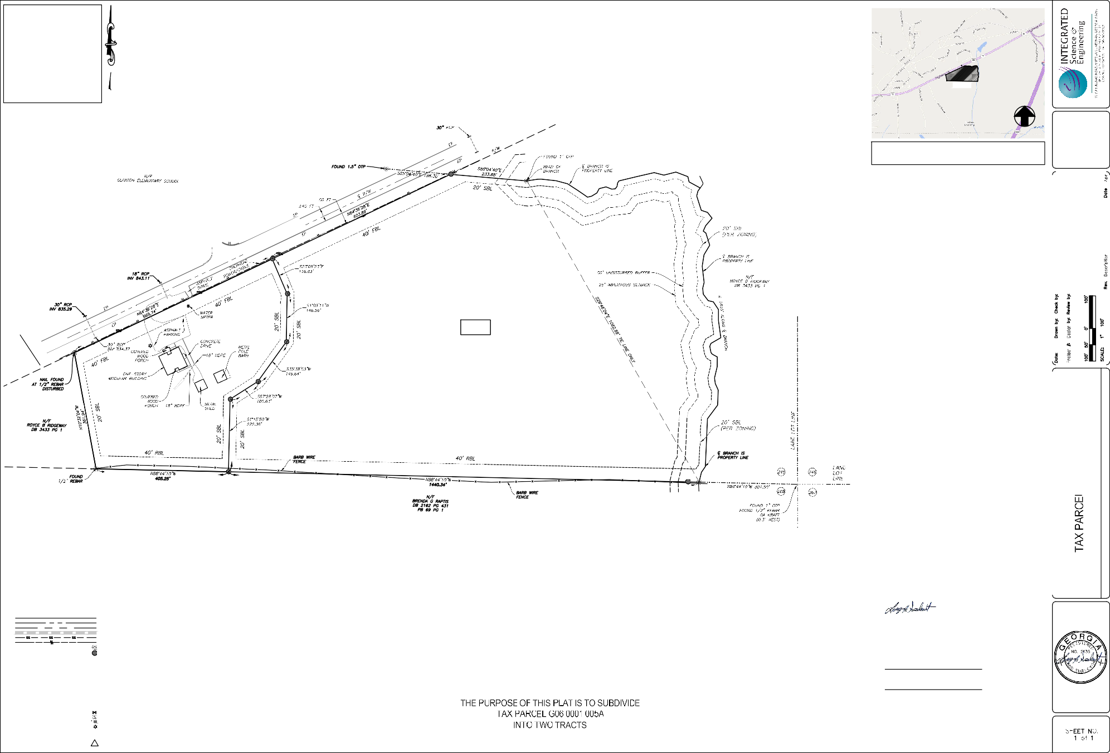SITE AREAS
NOTE 3
PARCEL 1 268,511.79 SQ FT
6.16 ACRES
PARCEL 2 1,180,860.39 SQ FT
27.11 ACRES
TOTAL AREA 1,449,372.18 SQ FT
33.27 ACRES

LEGEND
PROPERTY LINE
CENTER LINE OF RIGHT-OF-WAY RIGHT-OF-WAY LINE
STORM LINE
SANITARY SEWER LINE POWER LINE
IRON PIN FOUND AS NOTED
PROPERTY CORNER (HALF INCH REBAR & CAP SET) RBR HALF INCH REBAR
IPS IRON PIN SET OTP OPEN TOP PIPE
P.O.B. POINT OF BEGINNING
P.O.C. POINT OF COMMENCEMENT N/F NOW OR FORMERLY
RBC HALF INCH REBAR WITH CAP FBL FRONT BUILDING LINE
SBL SIDE BUILDING LINE RBL REAR BUILDING LINE
℄ CENTER LINE
WATER VALVE
SANITARY SEWER MANHOLE UTILITY POLE
LIGHT STANDARD
EP EDGE OF PAVEMENT R/W RIGHT-OF-WAY
12 TITLE EXCEPTION ITEM

CITY OF GRANTVILLE
FINAL PLAT APPROVED BY CITY ENGINEER OR PERSON DESIGNATED BY THE MAYOR, CITY COUNCIL OR CITY MANAGER OF THE CITY OF GRANTVILLE, COWETA COUNTY, GEORGIA.

DATE: SIGNED

APPROVED BY THE GRANTVILLE PLANNING COMMISSION.

DATE: SIGNED
PLANNING COMMISSION CHAIRMAN

AS REQUIRED BY SUBSECTION (D) OF O.C.G.A. SECTION 15-6-67, THIS PLAT HAS BEEN PREPARED BY A LAND SURVEYOR AND APPROVED BY ALL APPLICABLE LOCAL JURISDICTIONS FOR RECORDING AS EVIDENCED BY APPROVAL CERTIFICATES, SIGNATURES, STAMPS, OR STATEMENTS HEREON. SUCH APPROVALS OR AFFIRMATIONS SHOULD BE CONFIRMED WITH THE APPROPRIATE GOVERNMENTAL BODIES BY ANY PURCHASER OR USER OF THIS PLAT AS TO INTENDED USE OF ANY PARCEL. FURTHERMORE, THE UNDERSIGNED LAND SURVEYOR CERTIFIES THAT THIS PLAT COMPLIES WITH THE MINIMUM TECHNICAL STANDARDS FOR PROPERTY SURVEYS IN GEORGIA AS SET FORTH IN THE RULES AND REGULATIONS OF THE GEORGIA BOARD OF REGISTRATION FOR PROFESSIONAL ENGINEERS AND LAND SURVEYORS AND AS SET FORTH IN O.C.G.A. SECTION 15-6-67.

THE FIELD DATA UPON WHICH THIS MAP OR PLAT IS BASED HAS A CLOSURE PRECISION OF ONE FOOT IN 87,839 FEET, AND AN ANGULAR ERROR OF 3" PER ANGLE POINT, AND WAS ADJUSTED USING LEAST SQUARES. THIS MAP OR PLAT HAS BEEN CALCULATED FOR CLOSURE AND IS FOUND TO BE ACCURATE WITHIN ONE FOOT IN 2,545,534 FEET. EQUIPMENT UTILIZED: LEICA TS12 P 3".

6/3/22
LARRY J SEABOLT, PLS GA 2135 DATE INTEGRATED SCIENCE & ENGINEERING LSF000136

OWNER CERTIFICATION
WE, THE OWNER(S) OF SAID PROPERTY SURVEYED, DO HEREBY JOIN IN THE FOREGOING STATEMENT AND DO HEREBY CERTIFY THAT IT WAS AND IS OUR INTENTION TO DIVIDE SAID LAND INTO LOTS AS SHOWN BY SAID PLAT AND DO WARRANT THAT TITLE WAS VESTED IN US AS OF THE DATE OF THE CERTIFICATION.

OWNER DATE

OWNER DATE

6/3/22

Coweta County, GA

Overview

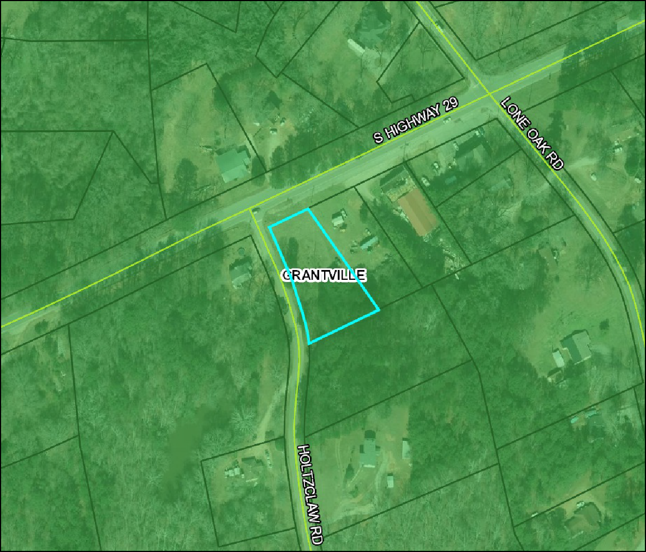Legend
208 ft

Parcels Roads Municipalities
CHATTAHOOCHE HILLS
GRANTVILLE HARALSON MORELAND NEWNAN PALMETTO SENOIA SHARPSBURG TURIN

Parcel ID G06 0002 008
Class Code Residential Taxing District GRANTVILLE 04 Acres 0.73

(Note: Not to be used on legal documents)

Date created: 7/6/2022
Last Data Uploaded: 7/6/2022 1:38:55 AM Developed by

Owner SELLS JAMES O
213 COLLIERSTOWN WAY PEACHTREE CITY, GA 30269

Physical Address n/a
Assessed Value Value $4007

Last 2 Sales
Date Price Reason Qual
8/7/2017 $7500 LM Q
9/30/1984 0 09 U

CITY OF GRANTVILLE REZONING APPLICATION

The undersigned hereby respectfully requests that the zoning district for referenced property and the City of Grantville Zoning Map be amended as described below:

I. Name of Property Owner/ Applicant: Hendon Properties/ c.o. Mark Tiller

- Applicant Address: 3445 Peachtree Road NE, Suite 465, Atlanta GA 30326

- Telephone No. (Day) 404.262.7400 Telephone No. (Evening) 404.271.0243

- EmaiI address of Appl icant:_m_lil_le_r@ h_en_d_o_n_pr_o_pe_rt_ie_s_.c_o_m _

- Address of Property: US Highway 29, Grantville GA 30220, no address currently designated

"6. Provide exact information to locate the property for which you propose a change:
Tax District Grantville 04 (District 04) , Tax Map Number_G_0_6 _
Parcel Number G06 0002 007 Area of subject property: 0.73 (Acres)
- Current zoning district of the property: (Check One) ( ) Rural Development (RD)
(X) Single Family Residential (R20)
( ) Multi-family Residential (R-6) ( ) Neighborhood Unit Plan (NUP) ( ) Parks & Recreation (PR)
( ) Commercial Residential (CR) ( ) Office & Institutional (01)
( ) General Commercial (GC) ( ) Light Industrial (LM)
( ) General Industrial (GI)

- What new zoning district do you propose for this prope1ty? General Commercial (GC)
(Under item 13 explain your reason(:,) for your rezoning request.)

- Do you own all of the subject property proposed for this zoning change?
( ) Yes (X) No (If no, then each property owner must sign an individual application.)
I 0. Is the property subject to the Historic Preservation Overlay District? ( ) Yes (X) No
- List the present use of property and any structures existing on the property.
Page I of 4

Property is currently undeveloped and unused.

- Intent of Rezoning: (Detailed Description of Proposed Development)
(Attach separate sheets as necessary. Indicate if additional pages are aflached)
Property will be consolidated with adjacent tract, which is already zoned GC
in order to develop a retail shopping building, with associated parking. a buffer reduction will also be required to reduce the residential buffer from 100' to 25' in order to accommodate the detention pond.
- Fee for Rezoning Application based on prope11y acreage to be paid in advance.
Rezoning Application Fee Determination:

Property Size (Acres)
1.27

Rezoning Fee/ Ac

Total Rezoning Fee
$200 I Ac

$254.00

(Maximum Fee $10,000)

- Docs the proposed prope1ty use require Development of Regional Impact (ORI) Approval?

( ) Yes (X) No

- Fee for DRI Application based on prope11y acreage to be paid in advance. This fee is in addition to Rezoning Application Fees.
Development of Regional Impact (DRI) Fee Determination:

Base Charge Property Size (Acres)
$3,000.00

NIA

ORI Application Fee/ Ac

Total DRI Fee
$20.00 I Ac

NIA

(Base Charge plus Fee per Acre)

I certify that I own the prope1ty described in this application or I am authorized by the owner(s) to file this application on their behalf.

= ,gnat
·
_j.(: hOJ\.k.& He.r-£:k,I') Jr
Printed Name

Attach completed Rezoning Applicatio11 Disclosure Form.

Page 2 of 4
Date 5- 9- 22.,

NOTE: The City will be responsible for posting the notice on the affected property in accordance with the CITY OF GRANTVILLE POSTING NOTICE REQUIREMENTS FOR ZONING MAP AMENDMENT APPLICATIONS.

All rezoning and or ORI fees must be paid in advance and are not refundable regardless of the final disposition of the application.

The Completed application will be reviewed first by the Planning & Zoning Commission at a regulal'ly scheduled voting meeting. After the application has been voted on and a recommended to Council, the property will be posted for public notice and to solicit comments from the public. Following public notice, the application must undergo two readings of Council.

Current Rezoning Fees and ORI fees are maintained by the City of Grantville. Information can be obtained by telephone at (770) 583-2289.

FOR PLANNING & ZONING DEPARTMENT USE ONLY
File Number - R2- Posting Notice Issue Date: Fees Paid by Applicant: _
Receipt Number:

Date Completed Application and Fees were received:

Page 3 of 4

REZONING APPLICATION DISCLOSURE FORM

Conflict of Interest in Zoning Actions Act Disclosure of Financial Interests

Under the guidelines of State Law, an application for Rezoning must disclose campaign contributions totaling $250.00 or more over the past two years to any City Council Member. This is inclusive of immediate family members and you/ they holding office positions in a business, firm or corporation.

Contributions have been made to the following officials:

(x) I have not made any contributions to City Officials.

By: 52
j. C..ros\.\¼ \ U\<lt.\)(\ -J(
Printed Name

Date_5_--_... _ _.,_ _7- _

* Attach additional sheets if necessary to disclose or describe all contributions.
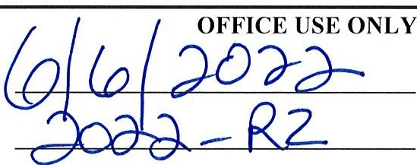

Date Received: File Number:
Page 4 of 4

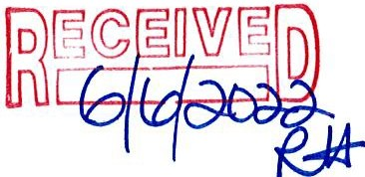
CITY OF GRANTVILLE REZONING APPLICATION

The undersigned hereby respectfully requests that the zoning district for referenced prope11y and the City of Grantville Zoning Map be amended as described below:

I. Name of Property Owner/ Applicant:_J_a_m_e_s_O_. S_e_ll_s _

- Applicant Address: 213 Collierstown Way, Peachtree City, GA 30269

- Telephone No. (Day) 404.262.7400 Telephone No. (Evening) 404.271.0243

- EmaiI address of Applicant:_m_ti_lle_r....;:@:;_h_e_n_do_n....:.p_ro--'p_e_rt_ie_s_.c_o_m _

- Address of Property: US Highway 29, Grantville GA 30220, no address currently designated

- Provide exact information to locate the prope11y for which you propose a change:
Tax District Grantville 04 (District 04) , Tax Map Number_G_0_6 Parcel Number G06 0002 007 Area of subject property: 0.73 (Acres)
- Current zoning district of the property: (Check One)

( ) Rural Development (RD)
(X) Single Family Residential (R20)
( ) Multi-family Residential (R-6) ( ) Neighborhood Unit Plan (NUP) ( ) Parks & Recreation (PR)
( ) Commercial Residential (CR) ( ) Office & Institutional (OJ)
( ) General Commercial (GC) ( ) Light Industrial (LM)
( ) General Industrial (GI)

- What new zoning district do you propose for this prope11y? General Commercial (GC)
(Under item 13 explain your reason(s) for your rezoning request.)

- Do you own all of the subject property proposed for this zoning change?
( ) Yes (X) No (If no, then each property owner must sign an individual application.)

I 0. Is the property subject to the Historic Preservation Overlay District? ( ) Yes (X) No
- List the present use of property and any structures existing on the property.
Page I of 4

Property is currently undeveloped and unused.

- Intent of Rezoning: (Detailed Description of Proposed Development)

(Attach separate sheets as necessary. Indicate if additional pages are attached.)
Property will be consolidated with adjacent tract, which is already zoned GC
in order to develop a retail shopping building, with associated parking. a buffer reduction will also be required to reduce the residential buffer from 100' to 25' in order to accommodate the detention pond.
- Fee for Rezoning Application based on prope1ty acreage to be paid in advance.

Rezoning Application Fee Determination:

Property Size (Acres) Rezoning Fee/ Ac Total Rezoning Fee
1.27

$200 I Ac

$254.00 (Maximum Fee $10,000)

- Does the proposed prope1ty use require Development of Regional Impact (ORI) Approval?

( ) Yes (X) No

- Fee for ORI Application based on property acreage to be paid in advance. This fee is in addition to Rezoning Application Fees.

Development of Regional Impact (DRI) Fee Determination:

Base Charge Prope,ty Size (Acres)
ORI Application Fee/ Ac

Total DRI Fee
$3,000.00

NIA

$20.00 I Ac

NIA (Base Charge plus Fee per Acre)

I ce,tify that I wn the property described in this application or I am authorized by the owner(s) to file this lication on their be f.
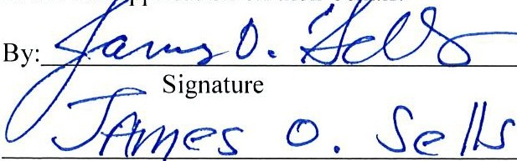
Date b - b 2-02-2---

Printed Name

Attach completed Rezoning Application Disclosure Form.

Page 2 of 4

NOTE: The City will be responsible for posting the notice on the affected property in accordance with the CITY OF GRANTVILLE POSTING NOTICE REQUIREMENTS FOR ZONING MAP AMENDMENT APPLICATIONS.

All rezoning and or ORI fees must be paid in advance and are not refundable regardless of the final disposition of the application.

The Completed application will be reviewed first by the Planning & Zoning Commission at a regularly scheduled voting meeting. After the application has been voted on and a recommended to Council, the prope1ty will be posted for public notice and to solicit comments from the public. Following public notice, the application must undergo two readings of Council.

Current Rezoning Fees and ORI fees are maintained by the City of Grantville. Information can be obtained by telephone at (770) 583-2289.

FOR PLANNING & ZONING DEPARTMENT USE ONLY
File Numbe f("2- Posting Notice Issue Date: Fees Paid by Applicant:
Receipt Number:

Date Completed Application and Fees were received:
Official Date Stamp,\\\\H }111JtJ1
.\. \\08 df) _,,,_.J4.

Page 3 of 4

REZONING APPLICATION DISCLOSURE FORM

Conflict of Interest in Zoning Actions Act Disclosure of Financial Interests

Under the guidelines of State Law, an application for Rezoning must disclose campaign contributions totaling $250.00 or more over the past two years to any City Council Member. This is inclusive of immediate family members and you/ they holding office positions in a business, firm or corporation.

Contributions have been made to the following officials:
Vo/Ve

fui_iavenot made any contributions to City Officials.

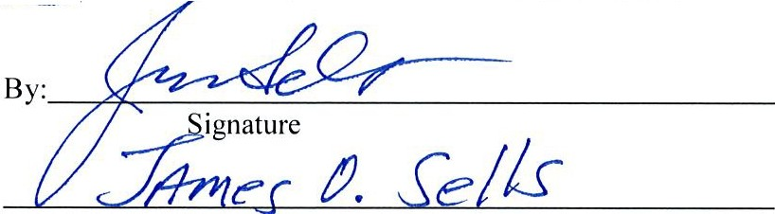
Printed Name

* Attach additional sheets if necessary to disclose or describe all contributions.

b( ( USE ONLY
0
Date Received:

File Number:

Page 4 of 4

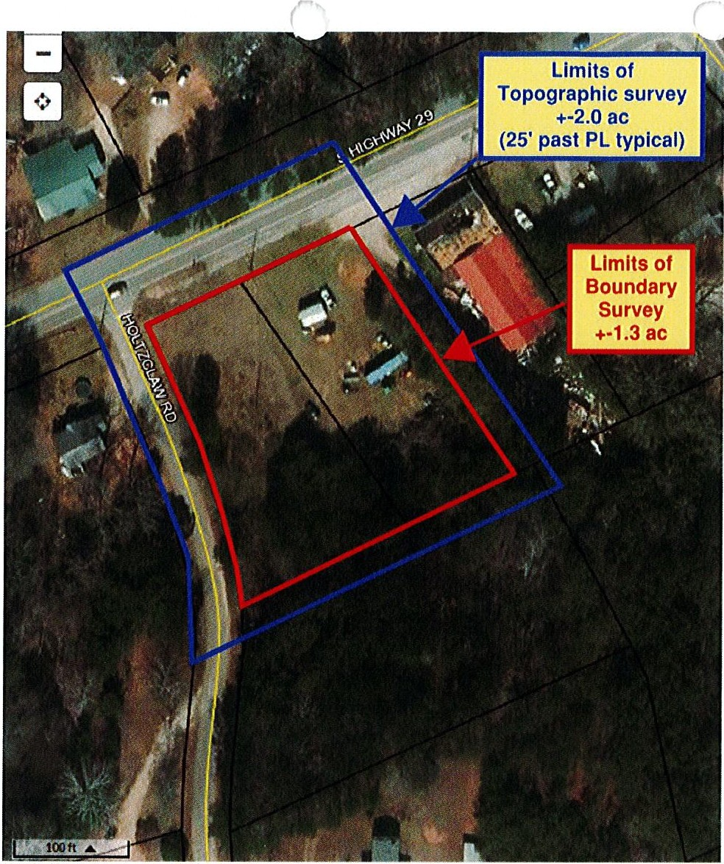

The proposal will be made out to:
Mark Tiller Jr. Hendon Properties
3445 Peachtree Road NE Suite 465
Atlanta, GA 30326
404-262-7400
mtiller@hendonproperties.com

We will need:
Alta Survey
Topo (1' contours) Underground utilities
All above ground utilities (including guide-wires from power poles)

Thank you and please let me know if you have any questions or need any additional information.

Respectfully,
Erick Garcia Salas
Owner
ErickG@TCG.Engineer
2

 | tt....-:0-:t°W.,  C,:,C-Y  r:,,..""U'-.' Vl,!-r,),)C  .. ·, «\l►  ():;  - not!>OJIIUNO:, | oo,ntn0t:J  SIDt:tOBt' 't!)d'vJta,VU.Yld.  .JJ.lftS')N(lllll31il tf  f\KXJ\a-1 | oa·uoa>cisvn :> :HOO. ,  tt6 | =2- -:: --:::._=-::AS |  | i§ | s  i} | N  0  0w.  uz  0  u | 0  0  u  8
 |  |  | JT'!V.U."AO J/0 JJO :NOU.:J,Ql5bl'W'
 |  |  | ,.,Vl.iWX)MOO, J Oll"iSSI
 |  |  |  |  |  | Ib
 |  |  | JN3WdO131130 11VJ3 |  | 31YOT |  | i 11
 |  |  |  | SNOISt/l.lli
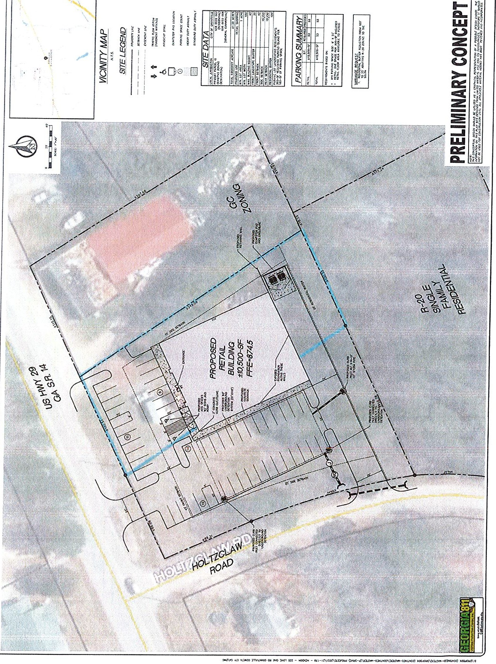

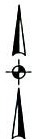
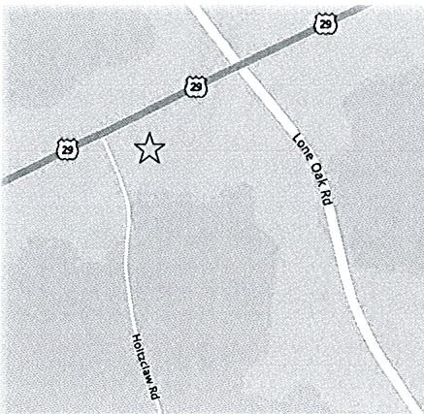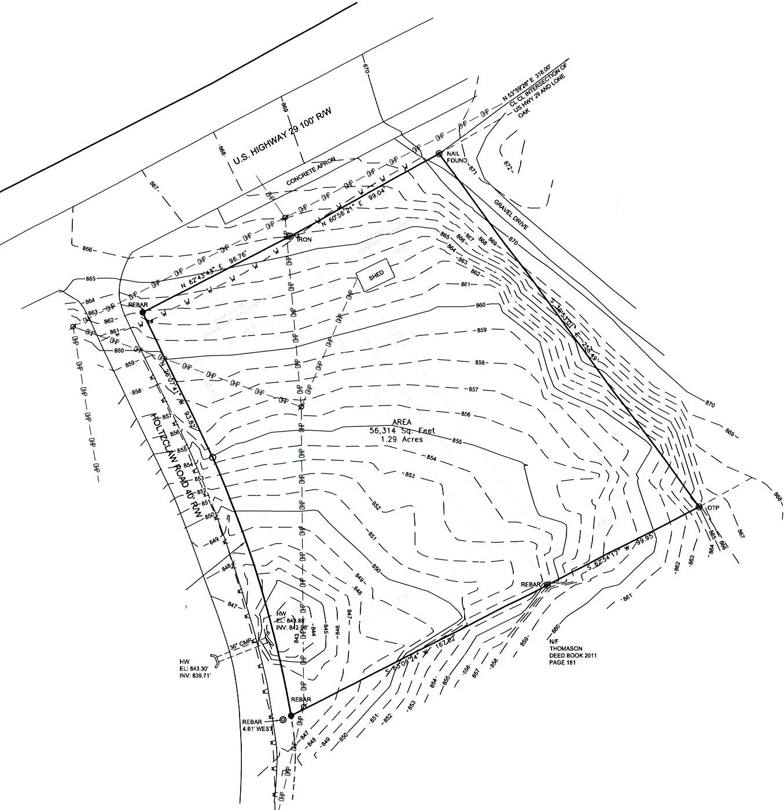VICINITY MAP
 |  | LEGEND
@ | lRONP FOUND |  | @ | AfflMONIJ!,,!f.'if
@ | IRONPINSET |  | BC | BACKOFCURa
 | PROPERTY CORIER
f1 | POW<RPOU |  |  | EA.SUI.ENT
ff) | FIIE HYORAHT | -•----- |  | OVERHEAD POWE
(D | TILEPHONE PEDESTAL
0  I! | WATER.METER  MOPM.ET
® | OMHOU

•

RLINE

RESERVED fOR Cl.ERK Of SUPERJORCOUU

BEARINGS A.RE BASEDON
PLAT&OOK 18 PAG£247

WF
SEU.S
OEED800K4834 PAGES45

* l-"HTPOU
RECORD LEGAL DESCRIPTION
THELANO REFERRED TOINCOti.UrTMENT MJIA8E:A 210000ll0601. ISSUEDBY STEWART Tm.£GUARANTY <XJ+M>A'l'f WITHANffFECTM DATE Of.AJLY10,2021.
ALL T TRACTOR PARCEL OFLANO LYWQ ANO8Etc0INLANOLOT 26'1OF THE al) OISfRJCl Of COW'ETA C()IMTY, GEOROIA ANO BEING MOREPARTICU.ARLY OESCAJBEO ASfOUOWS:

LOTS30AND31

AU THAT TRACTOR PARCEL OFLANOLYING ANOBEMJ 1H Tl£ CITYOf Gf\A.'ITVLli.EIN t.»«l LOT 269 Of l'HE?JD LAND OISTRICT OF COWETA COUNTY, GEORGIA.BEING OESCR18EOACCOROINO TO PLATOF SURVEY £NT1TlEO SURVEY FOR:l£SLYE TIPTON BY9US8EE SURVEYWG CO., INC. OATIDMAACtt 112005"'5FOUCNIS

BEGINNING AT A.POINT MARJ<EOBYANIRONPINSETON ™E SOVTHEASTEFtlY RIGKT-Of•WAY UNEOf U.S.HIGHWAY NO.29. WHICHPOtNT IS LOCATED A OiSTAHCEOf 48.SJFEET SOUTH36 DEGREES 40L'.INIJTES 20SECOHOS EASTOf A POINT IN 'THE CENT£RLfNE Of U.S.HIGHNO.29, 'NHICH CENTERL._E POINT IS LOCATUIA OISTANCEOf 32123FEET SOUTH42DEGFtEES<18 MLYJ'TI:S 02 SECOHOS WEST Of' TH£ IMTERSECTIOH OFSAID CENTERLINE WrTl4 THEC£NTfJtLINE OFLONEOAK ROAD, Al.SO SOMETIJ.ES KNOWN ASLUTHERSVILLE ROAD;

FROM SAJOPOINT Of BEG!Ni-.,NQ. RUNNINGSOUTH 36DEGREES 40MINUTES 20SECONOSEASl A DISTANCE 012'7.21FEET TOA POINTWIRKEO BY ANIRONPIHFOUND; THENCE R\JN1'ai0 SOUTH83OEQREES29MIHVTES 00 SECONDS WEST A DISTANCEOF100.00FEET TOAPOt<f MARKED BYAHIRONPINSET; TliENCERUNNING NORTH36DEGREES 41 MINUTES 12SECO,,OSV.'EST A DISTANCE.OF 2S3.5tFEETTOA POINT WAKED BYAHIROHPINSETONTHESOVTHE.ASTERI.YR)GHT-Of'•WAYLINEOFU.S.1-UGHWAY NO. 29; THEHCE RUNNINGM.ONG SA.JORIGHT-Of-WAYLINE N0RTii 81DEGREES 23 MIHVT'ES 00 SECONDSEASTA OlSTANCE OF100.00FEET TOTHE P0tHT Of BEGl"""1NG.

BEIHO THESA.\IEPROPERTY CONVEYED BYOEEOS RECOROEDAT DEED&00K89 PAGE 208, OEEO8001(1<185 pAGES390AN0392,ANOOEED
BOOI( 2527PAGES 294N#0297COWETACOUNTYRECOROS. TRACT8
ALLTHTCEA.TA.INTRACTPAR.caOFLANOLY'INGANDBEINOINTHE CO'YOF GRAHTVlllE, COYv"ETACOUNTY, GEORGIA, N LANOLOTffi Of THESfCOf,()LANO OISTRJCT CONTArN N,G7<18ACRESAHOBEINGIOEN'TIFIEOM TRACT8 Of PlATOf PROPERTYOf JW. HOLTZCl.AW ACCORDING TOMAP AHOSU BYJ0KHR.CHRJSTOPHER DATED1fllfl2,REVISEOlhJ/72AHO FURTHER REV'ISEO 9113172. A COPYOf WHICH SAIDPLAT IS RECORDED IN PLAT BOOK 18.PAGE 247, COWETACOUN'TY,GEORGIA 'Y:COAOS. OREf'ERENCETO'NHICHISHEREBY MADE FOR A MORECOMPlETE DESCRIPTION Of METES, BOUNDS, OOORSES AHODISTANCES.

NOTES CORRESPONDING TO TABLE A

O(•)A. Oe{b NOZONINGINFOFt.lAATlONWASPROVIOEO 8YCl.lEHT OFt CLIE.Ml'S OESIGN.J.TEO REPR£SEN1ATM: ZONING INFOfWATION
AHO8UILOINQ SETBACK LINESWERE08TAINEOFROM TI-IECITYOFGRAHTVIU.E, Al«) ARE SHOWN HEREON GRAPHICA.LlY.
II. THEREARE NOPAFOONO SPACESONSUBJECT PROPERTY.
11. UHOERGAOI.MO UTUTYPt.ANS WER.E NOT PRCMOEO8YCllEHT. ONLYTMOSE UTIUllES Jl-<AT ARE VISIBLE ABO\IEGROI.MO OR
LOCATED WITHSURFACE MA.RKINGS AA£ Pl.OlTEOHEREON.
16. NOEVIOENC£ Of EARTHWORK. BlJIU>IHGCOHSTRUCTIONOFtBUII.DINGAOOITIONSW£AE 08SERVED lNTHEPROCESS Of
CONJVCTlNGFIELDWORK
17. NOPROPOSED etw.GESOF RJGHT-OF-WAYMRE PRO\/IOEO.,.,,.,NOEVIOENCEOf STRE.ETCONSTRUCOONOR REPAIRSWEM:.
08SERVEO IN THE PROCESSOFCONOUCTING f1EL.D WORK.
111. ALL EASEMENTS OISClOSED OR 08TAINEO™-'TAFFECTSA!OPROPERTY O WERE ABLETO BEP\.OTTEO AA.E.PlOTTEO HEREON. NOOfFSITEEASOlEH'TS WEREOISClOSEO OR 08TAINEO.

NOTES CORRESPONDING TO SCHEDULE B

nfl:FOUOWINGEXCEPllONS ARELISTEDIN SCHEOlA.E 8, PAAT ■.OF A.COMMITMENT FOR TITI.EINSURANCE, AS PREPARED BY STEWART TTTlE GUARANTYCOMPANY. COMMWEHT NUMBER 21000090601, EFFECTIVE DATE JULY 10, 2021.

(A) DE.ED BOOK 50,PAGE450 fLOTS ANOl\J. OOESAFFECTPROPERTY ANO PLOTTEDHERE.OH

(8) PLAT 800I(16P,A.GE 247 fllt'CT 6).DOES AFFECTPROPEATVAHOIS PlOTTEO t£REON.

6-

A.157.24' R6l0.4 ·
N 1714'44• W
c,ss.e.r

AS SURVEY LEGAL DESCRIPTION
THElA."10REFER.RED TO NCOt,I.\UTMENT NIJf,,I.BER21000090801, ISSUEDBYSTEWARTTl1\.EGlJAJV.NT'Y OOMPN(YWITHAA EFFECTIVE DATE Of ..11.A.Y 10.2021 ISn4ESAME PROPERTY THAT WAS SLIRVEYE0,4'«J PlOTTEDHEREON,AHDDESCR18EOASFOUOW'S:

ALLTHAT TRACT ORPARCELOf LANOLvtNO ANOBl:INGIN THE ClTYOf GAAXT'Vlt.L.E IN LANOLOT269Of THE 2ND lAJflDISTRICTOf COWETA COl.tnY,GEOffGIA,BE.INGOESCAJBE.O ASFOUOWS:

BEGINNING AT APOIITT ONTHE SOUTHEASTERLY RIGHT-Of,WAYLNE Of U.S. HIGHWAY NO. 2i (100FOOT RIGKT-OF-WAY). WHICHPOINT IS LOCATED A DISTANCE OF318.00FEETsoont53DEGREES58 MINUTES 28 SECONOS WESTOf A POINTIN TME CENTERLINE OFU.S.HlGHNO. 29 Will(THEC£NTE.Ai.JNE Of'LONEOAKRO.-.O, ALSO SOMETIMES KNOWNASLLm£RSVM.LERO.-.O;
FROMSAIDTRUE POIITT Of SEGINNING. LEAVINGSAIDRIGHT-Of-WAY sount36DEGREES 53MINUTES01 S£00,.0S EAST A CMSTANCE. Of' 2!15<Ii l"EET TO A.POINT; THEHCE RU ING SOUTH12DEGREES5<1M:N\/TES 17 SECOl'C>SWEST A OISTN-ICEOF 911.95 FEETTOA POINT; THENCE RUNNING S0VTH63 OEGRE.ESWMIMJTES24 SECONDS WEST A CMST Of' 157.82FEET TOAPOINTONTHE EASTERLY RIOHT-Of•WAYLINE OF HOLTlCLAWROM> (40fOOT RIGHT-Of-WAY): TliENCEALOHGSAIORIQHT-Of'.WAY ALOHGACUAVE TOTl-E LEFT #l ARCDISTANCEOf 1 7.24 FtET(SAJOARC BEINGSUBTEN!){O 8Y ACHORD BEARING NORTli 17 DEGREES 1, M._UTES 14SECOM>S WEST AOIST Of 158.13 FEETI.NOA
RADIUS OF831U5FEET)TOAPOINT; THENCE R\INNWGALONOSAIORJGHT-Of.WAY NORTli 2t1DEGREES07 MINUTES '1 SECONDS WESTA DISTANCE OFlll.12FEET TOAPOINT OH nE SOIJTHEASTERLYRIGtfl'-Of,WAYUNEOf' U.S. HIGHWAY NO. tt THENCE RUNNlNGAI.ONG O RIGHT-Of:•WAYUNE NORTH152DEGREES '3 MINUTES <I SECONDSEASTAOISTANCEOf 96.78 FEET TOAPOINT:THENCERUNJ,jlNGALONG SA.JO
R.IGHT-OF•WAYUNE NORTMeo DEGREES SCIMlh'UT£S 21SECONDSEAST AOISTANCE Of 99.04 FEET TOAPOINT. 0 Tl£ TRUE PO:NTOf BEGINNING.

SAJOTRACTCONTAINS1.29 ACRES

ALTNNSPS LAND TITLE SURVEY
HENDON PROPERTIES, LLC STEWART TITLE GUARANTY COMPANY
JAMES 0. SELLS

COMMITTMENT NUMBER: 21000090601

SURVEYOR NOTES

THEFIELO OAlAUPONWKICH THIS MAPORPLAT ISBASED HASA ClOStJRf PRECISIClN Of ONEFOOT IN I1,858FEETN-fO ANGULAR ERROROF 3SECONDS PER ANGLE POIHT,AKJWAS NOT AD.NSTED. TlilSMAPORPLAT KM BEEN CALCULATED FORCLOSURE O IS FOUt«> TOBEACCURATE Wl'THINONE FOOT IN 99,173FEET. THETYPE OFEQUIPMENT USEDTO OOTAIN TliE LINEAR ANOANGUlAA MEASUftEMENTS USEO IH fl,£PREPAAATIONOf SAIDMAPOR PLAT ISANELECfROMC TOTALSTATK>N.

SlR',(Y(flCD.T'ffATOi

US HIGHWA.Y 29
PARCEL G060002 007& 0060002008
GRANTVILLE, GEORG!A 30220
LANDLOT 269 2ND DISTRICT
COWETA COUNTY GEORG!A
CllY OF GRANTVILLE

THE Ll'IOERSIGNEO BEJNGA REGISTER SURVEYOR Of THESTATEOF GEORGIA HERESY CERTIFIES TO STEWARTTRlE GUAAA.VTY
COMPAA'YOf ™E DATE BELOW. ASFOUOWS:

THIS PA.INl Of SURVfY ACTUALLY WASMADEONTHE GROONOON 07.29.2021IN ACCORDANCE WITHTliE"M.N!"4UM STANDARD
RfQIJIRfMEHfS FOR ALTA/'NSPS LANO nne s s.·JOINT\.Y ESTABLISHED A.."10 ADOPTEDBY ALTA.Nit> NSPSIN 2021,WITH
ACCVRACY ANO PRECISIONREQUIREMENT MODIFIED TOMEETCUR.REHT MIN!'-'UMANGUlAR ANOUNEA.R TOlERAHCE REQUIREMENT Of THE $TATE N WHlCH™E SUBJECT PROPERTY IS LOCATED. EXCEPT ASSHOWN ONTH SURVEYTHAT
{i) THEREARENOVlS!BLE DISCREPAHCIES, 00h1'LICTS,SHORTAGES IN AREAOR BOUNOARY LWE COHFUCTS:
f•J TME L.At.DDeSCRJ!N;O HEREINTOG£THER WITH All BUlt.DIHGSANOOVEMEHTS n£REON(THE "PROPE.RTY'") DOES NOT S£RVE
A..W.-.DJOIHINO PROPERTY FOR DRAINAGE, UTIJTIESOR IHGRE.SSIEGRESSUNLESSSHOWN,
(() THEPROPERTY HASACCESSTOAHOFROMA OU\.Y OEOCATED AHO ACCE.PTEO PU8l.lCRc»DNAY,
(/11) THISSlmV[Y REA.£CTS BOUNDARY LN:SOFTHE I.ANO, WHICH"CLOS£" BY EHGlNEERJNGCALCIA.ATIONS:
(v) ALLUTI.ITY SER'J'laS TO THE PRCN'£RTY Em£RENTER TH£ PROPERTY 11iROUGH AD..101."l:NG PVBllCSTREETS.ORTlilS SUR\1::Y SHOWS THE POINT Of ENTRY N«J LOCATlONOf NM IJTlLfllES'MUCH PASSTl4'tOuGH OR ARE LOCATED ON AOJOIN!NG PRNATE LANO TOTHEEXTEHTVISIBLEOR KNOWNTOnE Ll'IOERSIGHEO;
(I'[) THEPROf'ERTY 00£SNOTUE WITHINAN DESIGNATED ASAFl.000HAZARDAREABY NN MAPORPPUBUCATION Of' THEU,S OEPAA.TM£HTOf HDllS!NG ANDURSAN OEVELDPMENTORTHEFEDERAL EMERGENCY Jr,l»u,,GEMEHTAGENCY.
Ml) TliEPRCIP£RTY ANONLY THEPROPERTY CONSTITVTES ONE ORMORE SEPARATEAHOCOM?LETE TAXLOTS:A.'#J
('19)THERE AREHOENCROACHMENTS ON THE DESCRIBEDI.ANOBYANYO,!PRO'VEMEN'TS ON A.'IY ADJO[N!HG PREMiSESUN'..ESSSHO'NN,
NOEHCROACHMEHTS ONAOJOIN,NO PREMISESBYIMPROVEMENTS ONTHEOESCRIBEO I.AHOLl'ILESS SHOWN ANOTw.T THEREIS NO
APPAA.£.NT EVIOENCE OR SIGN Of M'Y EASEMENT CROSSING OR 81.IFt0£NINGOf' M'Y PART Of' nE LANOUl-l..f:SS SHOWN.

THE UNDERSIGNED KA.SR.EUMDANO EXAMINED A COPY Of THECOMMm.!EHT FORTin.£INSURANCE. 21000090601. DAT'EO.AJlY10, 2021,ISSUED8Y STEWART TmE GUARANTY 00,,S,AHYWITH RESPECT TO THEPROPERTY,ASWEU.AS ACOPY Of EACHINSTRUMENT LlSTEOTHEREIN. THELOCATIONOf EACH EXCEPTION SET FORTHINSUCHCOWJ.IJTMENT, TO THE EXTENT JTCA.."IBE LOCATED, HAS
{WITHRE.COROIHO RE.F'ERE.NCe ANO REFERENCE TO THEEXCEPTIONNUMBER OFTHECOMMITMENTI BEEN SH0WN1-EREON. THE UNDERSIGNED FURlltER CERTIFIES TMAT PURSUmT TO TliEACCURACY STANOAAO ASADOPTEDBY ALTAAHO NSPS INEFFECT ON

THIS Pl.ATISAR.ETRACEMEHTOf -'N E>OSTING PAACEL ORP.ARCELSOFLA ANOOOESHOTSUBOMOE.OR CR£AT"E A NEW PARCEL Ofl MAKEA.'ff OW,.,GEO TO AH'f REAi. PROPERTY BOUl'CARIES. THERECORO._GINFORMATION OF Tl-£ DOCVMEHTS, MA.PS, PLATS, OROTHER INSTRUMENTS WHICH CREATED TliEPARCEL ORPARCELS AAE.STATEOt£R.EON. R£C0ROAT'IONOfTHJS Pl.ATOOES NOT IMPlY APPRrNAl.Of AHYLOCAI...AJRISOICTK>N,AVM>BIUTYOF PERMITS, COMPl..lA.'«:.f WITHLOCAL REGUlATlOHS ORREQUIREMENTS, ORSUfTASILITY FORNNUSEOR PURPOSE Of T>IE LA'ro. AJRTHERMORE. THE UNDERSIGNED LANOSIJRVEYOR CERTIFIES Tw.T THISPLATCOMPLIES Wint THEWW.MUMTECtfllCAI..
ST.....OARDSFORPROPERT'YSURVEYS L"IGEORGIAAS SET FORTHIH THERULES ANREGlAATIOHS Of THEGEORGt.a.BOARD OFAEGISTRATIONFORPROFESSK>NAI. fHGjNEfRSANO LANOSURV'EYORS 4-.oASSET FORnt IN0.C.GA SECTION 1 7.

UTILITY NOTES
TI-ELOCATIONOf UTILff'ES SHOWN HEREON ARE rR0M oes oEVOEHCE OF"80\l'EOFtOUNO APPURTENAHCES N«J SURFACE
MARKJ-.GS Oh'\.Y, THE S OR WASNOTPROVIDED wrnt UNOEROFtOUHOPlAHSTOOET'ERMtiE ThELOCAT'IONOf loXYSUBTER.IWEAN USES. FROM GROl.1-oDAPPURTEN-\NCESANOSURFACE MARIONGS OM. YASSHOWN HEREON,ELECTRIC, GAS,ANO WAlEA. LINES ANOo'OR SEFIVICc IS AVAJl.A8LEFOR THE SU&JECT PROPERTY WITI-ltN A OE.OICATEO STREET OREASEMENT

FLOOD NOTES
THIS PROPERTY WASFOUM'.>NOT TOBELOCATED WITHIN FLOOO ZONE AE. OF THEFLOOOINSURANCE. RATE MAP, COMMUNITY PANEL
NUMBER 13077CXl3520WHICH BEARS ANEFFECTIVE OA.TEOF 0 13 NOFJELDSURVt::YING WASPERFORMED TODETERMINE THIS ZONE ANO A.NELEVATIOH ctRTIFICATEMAY BENEEDED TOV£RlfY THIS 0£TERMINA.TIOHOR ANAPPLICATION FOR A.VARIANCE FROM

TIC51SlOC81'TfYniil.TT-t$1W'CAP.ATNOMSl.lMYCJri'MtC>llT$8,l,SEOYID!lMia:JriliCt'/Yl!)A,'C£.lllffljf,£ 11t..._.,ST.w'.W!ClflAl .'O"I ALlA!o$>SVKlfflUSL1MYS,JOt;i. aThYJSo£1NCIA'»'rmlYAI.TAA'(IH:9S,NCltlCUa:fTUIIS1,1l.',1.11,14,M.11111 TMl.l TIOEallf:rl1D W.i:iCOY'I.ETlDCJriGf .
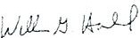
$CXl.l\lllE

WUWIG.tWaJOI.
VKJ$,Rl{YCRI() XO!

HARBUCK LAND SURVEYORS, INC.

lNIOSl.lNEYOR FIRMHO. lle;Q
30 0

THE DATEOf THISCERTIFM:ATIOH, THES MEASUREMENTSWERE MADE IN ACCOROANCe wmt THE"MINIMUM A."IGLE, OiSTAHCE,
A.'«Ja.OSUREREOUIREMENTS FORSVRYEY L'.EASUREMENTSVYi-UCH CONTROL LA.IC>B0UNOARIESFORALTA.INSPS LANO TinE
SURVEYS•,
i--•c-
15 30 60

GRAPHIC SCALE 1N FEET
THE FEDEAAI. EMERGEHCY Jr,1.AKA.GEMENT AGENCY.
TEl.EPHONE: nG--2Sl-6585
WIL.1.IAMG. HAABUCK GEORREGISTERED lA"IO SURVfYOR NO. JOOCi

HARBUOCLA'«>SURVEYOR50Gw.Jl..COM
5-3C JEFFERSON STREET
NEWNAN, GE:ORGIA 30293

PlATOATE:06.18.2021 flELOOATc:07.29.20'21 SCALE: 1"•30' REV.OATE:OSl.02-2021 EETIOF1

860
RETAIL DEVELOPMENT

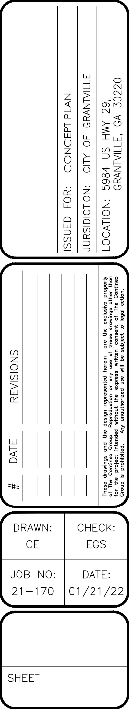REBAR

CONCEPT PLAN 5
C100

IRON

NAIL
FOUND

N/F
SELLS
DEED BOOK 4834
PAGE 545

OTP
0 20' 40'

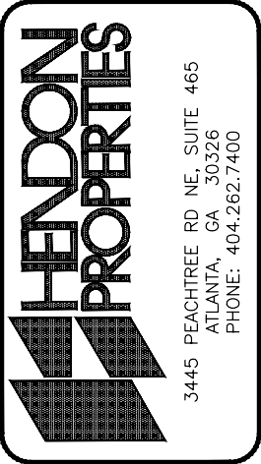

DETENTION POND

REBAR

HW

847
EL: 843.88'
INV: 842.96'

HW
EL: 843.30'
INV: 839.71'

N/F
THOMASON DEED BOOK 2011
PAGE 181

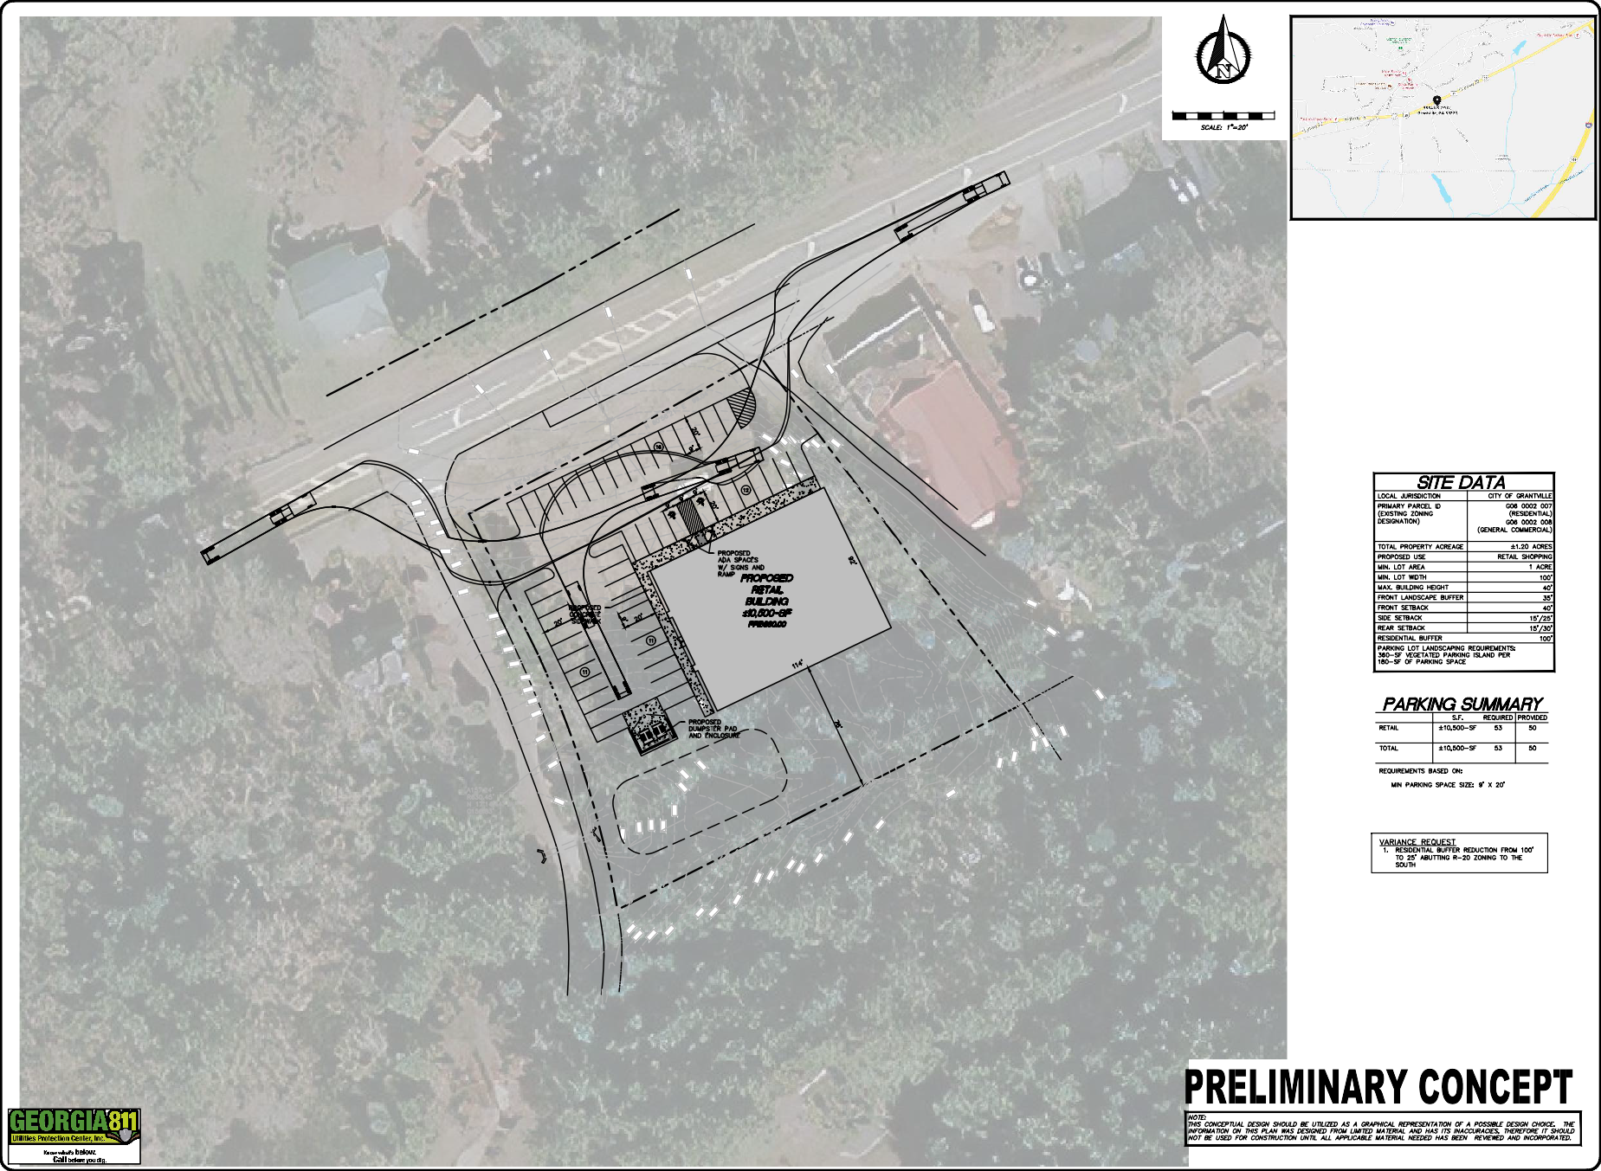
CONTINEO GROUP
755 COMMERCE DRIVE
SUITE 800
DECATUR, GA 30030
770.335.9403
www.tcg.engineer

REBAR

REBAR
4.61' WEST

860
RETAIL DEVELOPMENT

REBAR

CONCEPT PLAN 5
C100

IRON

NAIL
FOUND

N/F
SELLS
DEED BOOK 4834
PAGE 545

OTP
0 20' 40'

DETENTION POND

REBAR

HW

847
EL: 843.88'
INV: 842.96'

HW
EL: 843.30'
INV: 839.71'

N/F
THOMASON DEED BOOK 2011
PAGE 181

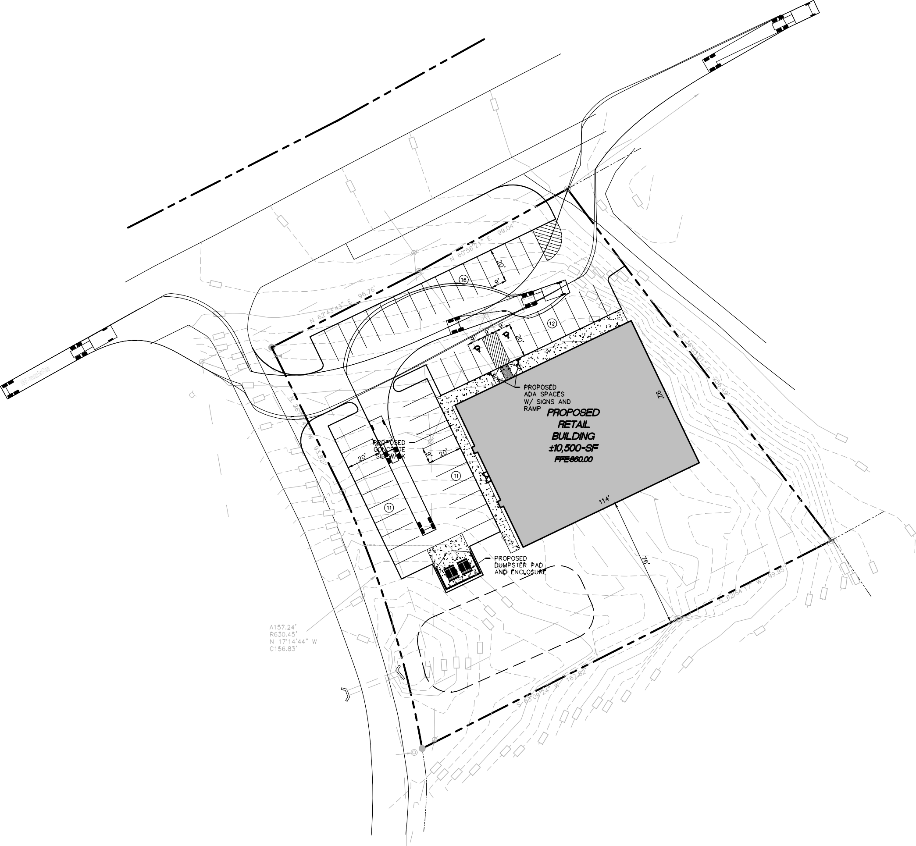
CONTINEO GROUP
755 COMMERCE DRIVE
SUITE 800
DECATUR, GA 30030
770.335.9403
www.tcg.engineer

REBAR

REBAR
4.61' WEST

