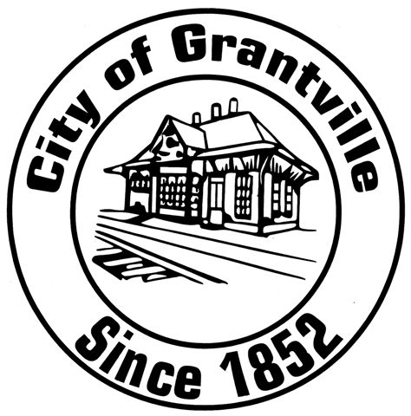

City of Grantville
Application for Commissions & Boards

Please note: This application is considered to be public record

Date:

I am interested in being considered for appointment to the following commissions and boards:

______ Historic Preservation Commission

______ Planning Commission

______ Ethic Board

Name of Applicant: _______________________________________________________

Home Address: __________________________________________________________

City: __Grantville___________ State: GA Zip Code: ___________________

Home Phone: ____________________ Email: _________________________________

Number of Years as Grantville Resident? ______________________________________

Nominated by (if not by self): _______________________________________________

Occupation: __________________ Business/Company Name: ____________________

Work Address: ____________________ City: _______________ Zip Code: _________

Work Phone: ______________________ Fax Number: __________________________

Preferred Mailing Address: ___ Home ____ Work

Do you currently serve on any Grantville Commissions/Boards? __Yes __No
If so, which one(s)? ______________________________________________________

Degrees earned and schools attended: ________________________________________
Professional experience (including professional memberships and previous employment): ________________________________________________________________________

Community Activities (including civic clubs, volunteer activities, service organizations, etc): __________________________________________________________________

Comments/special qualifications: ___________________________________________
______________________________________________________________________

Why do you want to serve on this commission/board? __________________________
______________________________________________________________________
______________________________________________________________________

Thank you for your interest in volunteering to serve on a City of Grantville commission or board! The duties and responsibilities vary greatly, however members are expected to attend all regularly scheduled meetings (most commissions/boards meet once monthly). Additional responsibilities will often include conducting independent research outside of these regular meetings in furtherance of the goals and objectives of the commission or board.

Instructions for Submitting Completed Application

Once the application form has been completed please turn into City Hall.

Signature: ______________________________________ Date: ___________________

