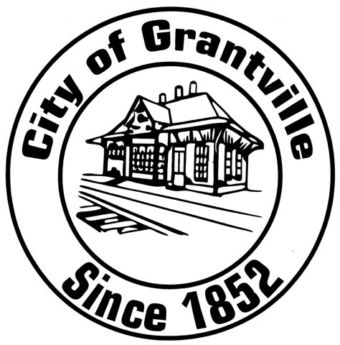
City of Grantville
Historic Preservation Commission
123 Lagrange Street, Grantville, GA 30220
Telephone: (770) 583-2289
Fax: (770) 583-2280

HOW TO OBTAIN A CERTIFICATE OF APPROPRIATENESS
IN THE CITY OF GRANTVILLE, GEORGIA
1. Contact Grantville City Hall for an application form (please use the contact information listed above).
2. Complete the application. Please provide as much of the supporting material as possible. For new construction, or major projects, a site plan, scale elevation drawings, including the new construction elements and indicating the building materials to be used, are required. Six (6) copies of plans or renderings for any new structure must be filed. Photographs of the subject property may be required. The Commission reserves the right to require additional information as necessary.
3. Submit this application, and all supporting information to the Grantville Historic Preservation Commission, at above address, by the required deadline of ten (10) days before the meeting date. Materials submitted for review must match what is presented or the application WILL be tabled until the next meeting.
4. The Historic Preservation Commission generally meets on the first Monday of each month at 6:00 pm in the Council Chambers at Grantville City Hall (123 Lagrange Street). If there are no pressing issues or applications to discuss, the Commission may choose not to meet. Please call ahead to confirm meetings. Applications received by the deadline will be considered by the Historic Preservation Commission. A sign will be posted on the subject property at least seven (7) days before the meeting date.
5. Applicants are welcome and encouraged to attend Historic Preservation meetings. Commissioners frequently have questions that only the applicant, or a knowledgeable representative of the applicant can answer.
6. A decision must be made by the Historic Preservation Commission within 45 days of the filing of an application for a Certificate of Appropriateness. Applications must then be approved, rejected, or approved subject to specified conditions. Appeals of decisions of the Historic Preservation may be made to the City Council. Please contact the City Manager’s Office (also at Grantville City Hall) if you wish to appeal.
7. If an application is approved or approved with conditions, and following a 15-day delay for possible appeals to the City Commission, the applicant may seek a building permit at Grantville City Hall. The issuance of a Certificate of Appropriateness by the Historic Preservation Commission does not relieve the applicant of the responsibility to meet any other requirements for obtaining a development or building permit.
8. The Commission encourages applicants to discuss planned projects with staff before the formal submission of the project.
APPLICATION FOR CERTIFICATE OF APPROPRIATENESS
City of Grantville Historic Preservation Commission
123 Lagrange Street, Grantville, GA 30220
770-583-2289, 770-583-2280 (fax)

1) Legal Address of Property: ______________________________________________________
______________________________________________________

2) Location:

a) District ____________________
b) Land Lot ____________________
c) Block ____________________
d) Parcel Number ____________________

3) Owner: ________________________________________________________________________

a) Owner’s Mailing Address: _____________________________________________________
_____________________________________________________

b) Owner Phone Number(s): Business: ______________________________
Cell: __________________________________
Home: __________________________________

c) Owner E-mail: _________________________________________________________________

4) Name of Applicant (Complete this section only if different from owner. If different, please attach Authorization form): ___________________________________________________________

a) Applicant’s Phone Number(s): Business: ______________________________
Cell: __________________________________
Home: __________________________________

b) Applicant’s E-mail: ______________________________________________________________

c) Relationship of Applicant to Property Owner:

__Owner __Architect __Contractor __ Tenant __ Other*

*if other, please explain __________________________________________________________

5) Age of Structure: Approximate date of construction for the primary structure on this property and of any secondary structures affected by this project: ___________________________________________________________________________________

___________________________________________________________________________________

6) Nature of proposed work (check all that apply):
a) ____ Addition b) ____ Deck or Patio
c) ____ Demolition d) ____ Exterior Architectural
e) ____ Exterior Environmental Feature Change f) ____ Fence/Wall
g) ____ Landscaping h) ____ Moving existing structure
i) ____ New Construction j) ____ New Freestanding Building
k) ____ Other l) ____ Repairs or Alterations
m) ____ Sign Erection or Replacement

7) Please describe your proposed work as simply and as accurately as possible. Use the attached submittal criteria checklist as your guide for your description. Be sure to indicate building and/or landscape materials to be used. Accurate drawings and photographs are required. You may use extra sheets, if necessary.

__________________________________________________________________________________________________________________________________________________________________________________________________________________________________________________________________________________________________________________________________________________________________________________________________________________________________________________________________________________________________________________________________________________________________________________________________________________________

IMPORTANT: This form must be completed BEFORE the Historic Preservation Commission can consider the approval of any material change to a Historic Property or a property within the Historic District. This form, along with all necessary supporting documentation (plans, material samples, color samples, and photos), must be filed with the Historic Preservation Commission staff. Two (2) copies of plans or renderings for any new structures must be filed.

All applicable items from the attached checklist of Submittal Criteria must be addressed. The Historic Preservation Commission will not docket incomplete applications for consideration.

I have read and understand the terms of this application. All information stated above is accurate and complete to the best of my knowledge.

Signature of Applicant: ________________________________________ Date: ___________________
CITY OF GRANTVILLE – HISTORIC PRESERVATION COMMISSION
CERTIFICATE OF APPROPRIATENESS
SUBMITTAL CRITERIA CHECKLIST

This list is designed to help you through the application process. Please bring with you the items checked on this list when you file your application for a Certificate of Appropriateness. If you feel that any of the other items in this list could help the Historic Preservation Commission to better understand your application, you may provide them as well.

□ Existing Site Plan
□ Proposed New Site Plan
□ Front Elevation
□ Rear Elevation
□ Left Elevation
□ Right Elevation
□ Floor Plan
□ Roof Plan
□ Detailed Drawings
□ Photographs of buildings and other areas affected by the proposed changes, including at least one photograph of any elevations which will be impacted, and at least one photograph of the precise areas where the work will be done.

□ Photographs of the front elevation of your building and the buildings to either side
□ List of materials to be used
□ Description of work to be completed
□ Specifications
□ Plan showing proposed changes to the landscape
□ Topographic plan of your property
□ If application is not being filed by property owner(s), please submit the appropriate authorization form from owner(s)

□ Other helpful information ___________________________________________

AUTHORIZATION OF A SECOND PARTY* TO APPLY FOR A
CERTIFICATE OF APPROPRIATENESS WITH THE
CITY OF GRANTVILLE – HISTORIC PRESERVATION COMMISSION

I/We, __________________________________________________________________________

being the owner(s) of the property described below or attached, located at the address of

_____________________________________________________________________ within the

City of Grantville, Georgia, hereby delegate authority to ______________________________

_______________________________________________________________________________

for the purpose of filing for a Certificate of Appropriateness with the City of Grantville’s

Historic Preservation Commission on my/our behalf.

Owner(s) Signature: ________________________________________________

Date: ____________________

*If someone, other than the owner, submits an application for a Certificate of Appropriateness, this form must be attached to the application upon submittal.

